Working With Data DATA9910
Lucas Rizzo
email: lucas.rizzo@tudublin.ie

- TO DO: check out PHD options with Lucas!! – l
- http://lucasrizzo.com/
- https://lucasrizzo.com/index.php?action=proposal
- Contact = lucas.rizzo@tudublin.ie (outside of class hours)

Week 1 – Set up Environment and R Notebook

Intro

About me
- TU Dublin lecturer since 2020.
- MSc coordinator. Any questions about dissertation proposals give me a shout or check the MSc dissertation website.
- I’m from Belo Horizonte - Brazil and I have been living in Dublin since 2015.
- My research focus is on Artificial Intelligence, more specifically automated reasoning and computational models of argument.
- If you are interested in these topics you can have a look at my website.

Lectures
- Full-time programme TU059
  - Mondays 16:00-18:00
  - Wednesdays 11:00-13:00
  - All classes and labs onsite (unless otherwise stated)
- Part-time programme TU060 and Data Science Certificate TU256
  - Thursdays 18:00-22:00
  - Onsite CQ007 (and mirror online) Week 1, Week 6, and Week 13
  - Online classes, Week 2-5, Week 7-12

Communication Statement

- Outside class hours, we should communicate primarily through email: lucas.rizzo@tudublin.ie
- You can send me emails any time, and it should be answered in 1 or 2 days maximum.
- Pay attention to emails and announcements for this module in Brightspace! That is how I will let you know about updates or any recent changes in the module.

Online material
- Materials available through Brightspace
- Search for Working with Data DATA9910
  - Lecturer Lucas Rizzo
  - Be sure to enroll in the right programme, TU059 or TU060/256 as in the description of the course.

Reading list - Essential
- Essential Reading:
  - Wickam & Grolemund, R for Data Science, O’Reilly Press, 2016. Free at https://r4ds.had.co.nz/
  - Andrew O. Finley, Jeffrey W. Doser, Vince Melfi, R Programming for Data Sciences. 2020. Free at https://bookdown.org/rdpeng/rprogdatascience/
  - McKinney, Wes. Python for data analysis: Data wrangling with Pandas, NumPy, and IPython. " O'Reilly Media, Inc.", 2022. Open access HTML https://wesmckinney.com/book/

Reading list -Supplemental

Supplemental Reading:
- Bruce, Peter, Andrew Bruce, and Peter Gedeck. Practical statistics for data scientists: 50+ essential concepts using R and Python. O'Reilly Media, 2020 -
001.422 BRU
  - (for those who need a detailed introduction to essential concepts in statistics)
- Rafael C. Gonzalez, Richard E. Woods., Digital image processing, Pearson, 2017
  - (for those interested in getting in-depth knowledge of image data)
- Sweigart, Automate the Boring Stuff with Python, No Starch Press, 2019
  - (for those unfamiliar with Python)
- Beaulieu, Learning SQL, O’Reilly Media, 2020 Hands on Programming with R: free here
  - (for a more practical approach learning R)
- Beaulieu, Learning SQL, O’Reilly Media, 2020
  - (for those unfamiliar with SQL)d

Tech Stack

Python |  | R
pandas | requests | devtools | Rraven
matplotlib | scikit-image | warbleR | maps
numpy | os | ggplot2 | tuneR
sqlalchemy | scipy | lattice | seewave
psycopg2-binary |  | readr | signal
sqlalchemy_schemadisplay |  | rvest | audio
pillow |  | DBI | odbc
ipython |  | RPostgres | blob
jupyterlab |  | dplyr | titanic
seaborn |  | dbplyr | rlang

PostgreSQL
- Pgadmin4 (GUI)
- PostgreSQL server
Notebooks
- Jupyter (.ipynb)
- R (.rmd)
Data Camp 
- You can access DataCamp courses for extra practice (that is highly recommended)
- Please create an account with the @mytudublin.ie domain to have free access to all courses through the link below
Link to register on DataCamp
- Some courses that might help you in the first weeks (not all there is covered in this module):
  - Intro to Python for Data Science
Intermediate Python
- Introduction to R
- Introduction to importing data to R
- Web scraping in R

Recordings

- Recorded lectures (if recorded) are available in Brightspace.
  - Go to Module Tools > Virtual Classroom
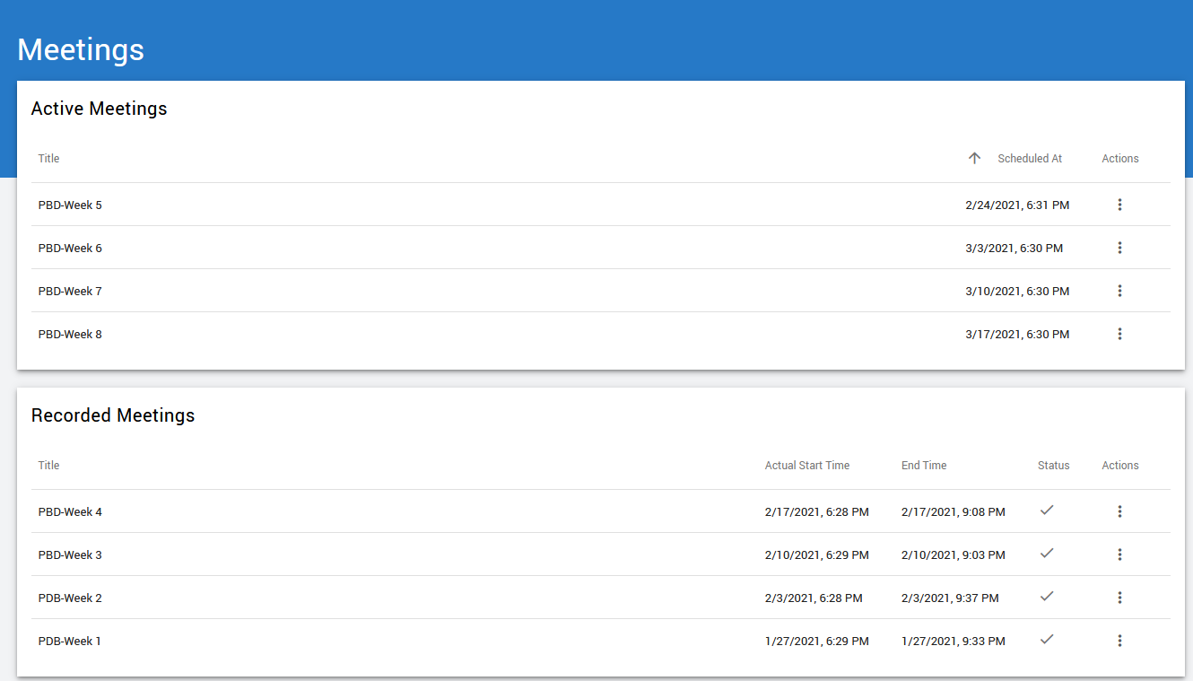#

Content

- Foundational module for data science

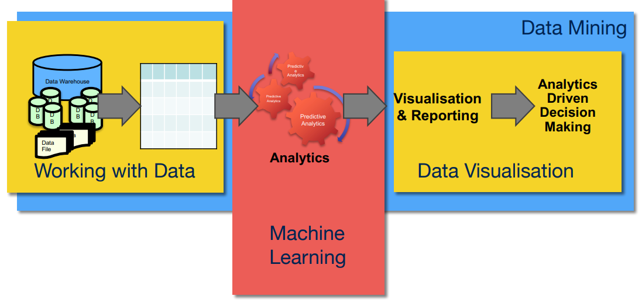
Eamonnk -Not sure what the above means

Assessment

- Lab assignments (40%). Some labs are marked and will need to be submitted
  - SQL programming and data centric languages (Python/R) (20%) (Week 5)
  - Image data lab (10%) (Week 10)
  - Audio data lab (10%) (Week 11)
- Continuous assessment (60%). Week 13
  - Select a dataset and create a notebook (data collection, cleaning, merging and some visualisation)

Indicative schedule

Week 1 | Set up environment and R notebook
Week 2 | Review Python and practice
Week 3 | Review R, importing data
Week 4 | Intro SQL and aggregate queries
Week 5 | Databases and scripting languages (To be submitted)
Week 6 | Interpreting Data (summary statistics, data visualisation)
Week 7 | Review week
Week 8 | Data manipulation in R
 | Pandas and Numpy
Week 9 | Data visualisation in Python
 | Data processing (regular expressions)
Week 10 | Audio data (R and tuneR) (To be submitted)
Week 11 | Image data (Python and skimage) (To be submitted)
Week 12 | Time series (Python and Pandas)
Week 13 | Working on Assignment
 | Assignment deadline

Week 1 | Set up environment and R notebook
Week 2 | Review Python and practice
Week 3 | Review R  Importing data with R
Week 4 | Intro SQL and aggregate queries
Week 5 | Databases and scripting languages (To be submitted)
Week 6 | Interpreting Data (summary statistics, data visualisation)
Week 7 | Review week
Week 8 | Data manipulation in R  Pandas and Numpy
Week 9 | Data visualisation in Python  Data processing (regular expressions)
Week 10 | Audio data (R and tuneR) (To be submitted)
Week 11 | Image data (Python and skimage) (To be submitted)
Week 12 | Time series (Python and Pandas)
Week 13 | Working on Assignment  Assignment deadline

This week Tasks

- Download and Set Up R and R-Studio
- Download and Set Up Python and Jupyter Notebook (see slides)
- Explore the Sample R Notebook File

Questions?

Content

Installing Python
- There are lots of ways to install Python. I recommend the official installer or Anaconda.
- If you already have Python installed check your version by opening a terminal and running
  - >>python --version
  - It should show something starting with 3
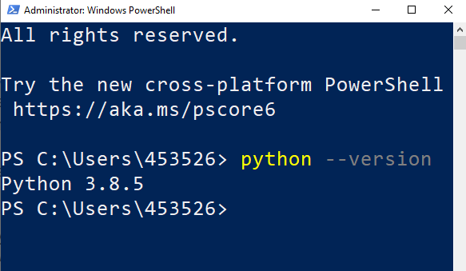

Installing on Windows

- Download Python from https://www.python.org/downloads
- Make sure you check the option to Add Python to your PATH
- Once the installation is
complete, open up a
terminal and check
your version as
shown previously

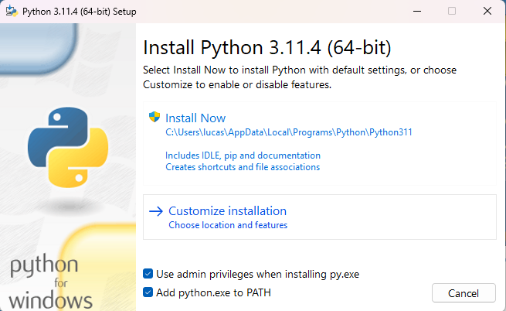

Installing on Mac / Ubuntu

- Newer versions of MacOS ship with Python 3 by default
- If you’re running MacOS and don’t have python head to the downloads page on the official website to install it
  - https://www.python.org/downloads/
- Python 3 can be installed on Ubuntu using apt
  - >>sudo apt install python3.11

PIP

- PIP is a package manager for Python packages, or modules if you like.
  - If you have Python version 3.4 or later, PIP is included by default.
- A package contains all the files you need for a module.
  - Modules are Python code libraries you can include in your project.
- Check if PIP is Installed
  - >>pip --version
- If you don’t have it, follow this guide https://pip.pypa.io/en/stable/installation/
- To install a Python package open a terminal and run
  - >>pip install <package name>
- For example, to install numpy you would run
  - >>pip install numpy
- More info commands using PIP here
  - https://www.w3schools.com/python/python_pip.asp

Notebooks

- Notebooks are interactive documents that allow you to combine code, text, and multimedia elements into a single file.
- It makes commenting your code much easier and allows you to interactively edit the code and run it from your web browser (if you want)
- In this course we will be using them for basically everything (studying, assignments, labs, etc.)
- We will be using two types of notebooks:
  - Jupyter Notebooks (.ipynb file extensions) that can handle Python and R kernels.
  - R Markdown notebooks (.rmd file extension) that can only handle R kernel.
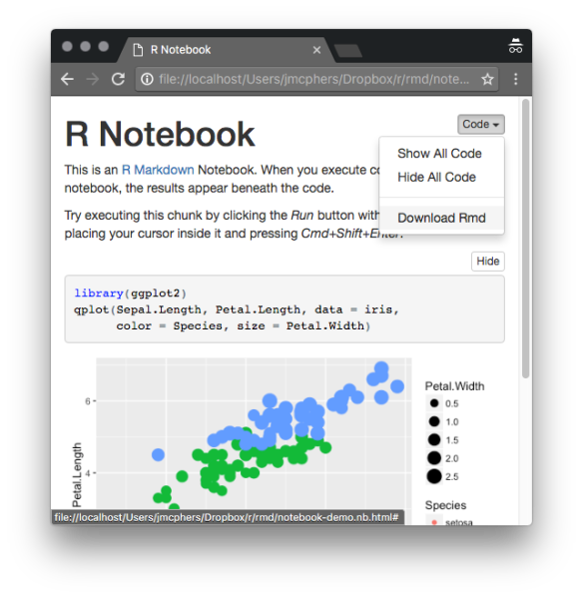

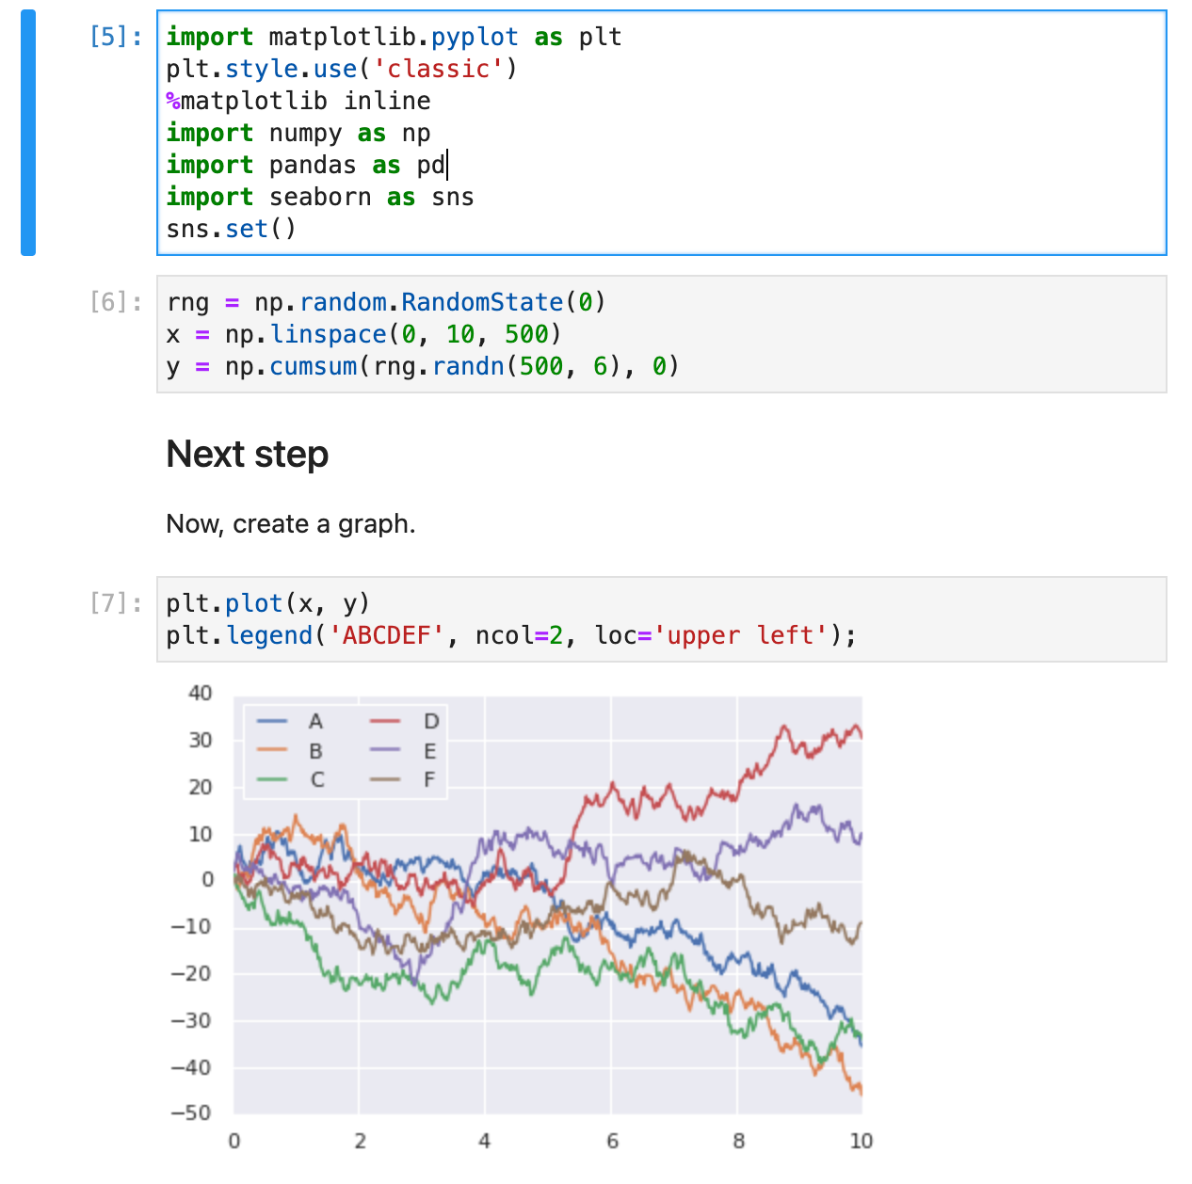

Installing Jupyter - 1

- Jupyter Notebook is a software that lets you combine text markdown with Python/R code
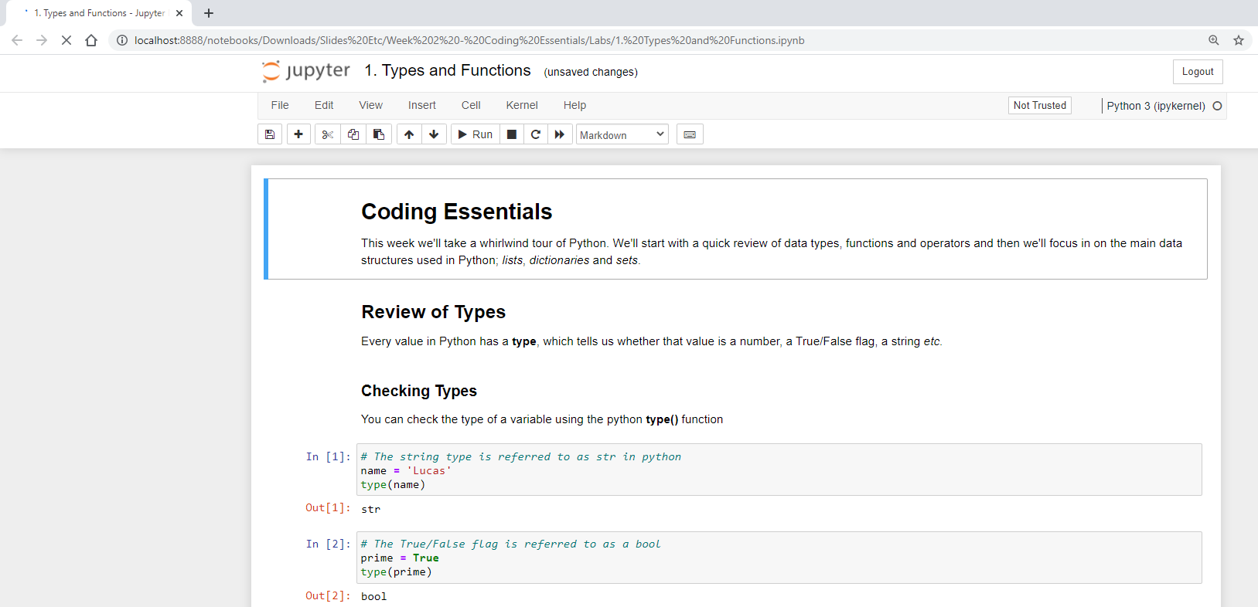

Installing Jupyter - 2
- You can install Jupyter using pip (but the module is actually called notebook)
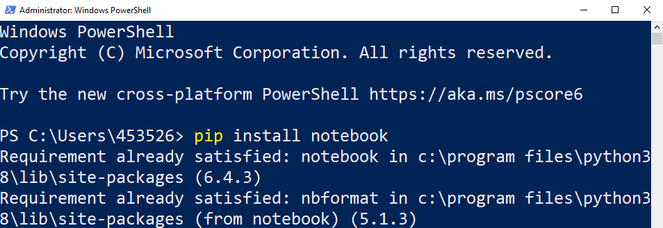

Installing Jupyter with Anaconda 
- You can use Anaconda to help you manage Python open-source packages.
- Anaconda is a Python/R data science distribution that contains conda, a package and environment manager, which helps you manage open-source packages available to them.
- It is good if you want to manage several Python/R environments, with different versions and packages. It also gives you a better interface to handle your packages.
- The main issues are that it can be very slow when updating and installing packages and R packages might be harder to find.

Anaconda 

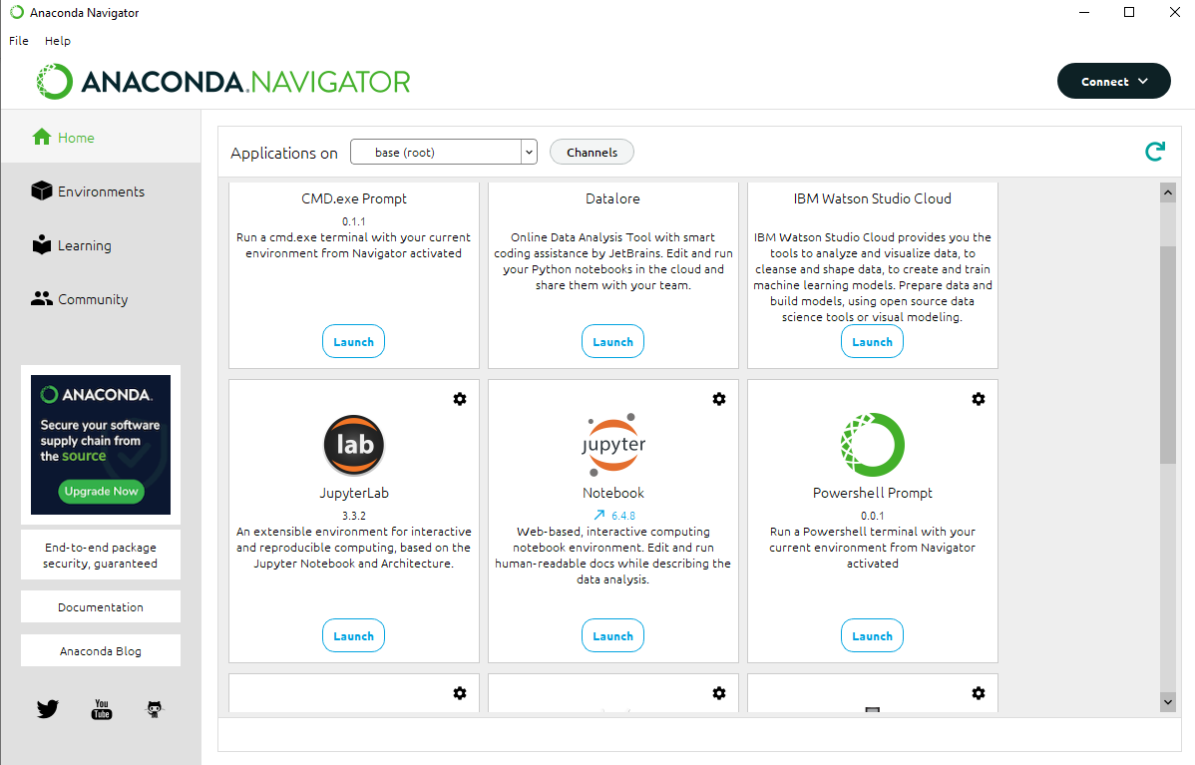
- Detailed instructions, including other operating systems, can be found here (it should be easy). > https://docs.anaconda.com/anaconda/install/
- You can check Anaconda starter guide > https://docs.anaconda.com/free/anacondaorg/user-guide/getting-started/
- Conda cheat sheet > https://docs.conda.io/projects/conda/en/4.6.0/_downloads/52a95608c49671267e40c689e0bc00ca/conda-cheatsheet.pdf

Using Jupyter Notebook (from command line)
- To start jupyter open a terminal and switch to the directory containing your code and run the notebook command
- For example, if your code is in a folder called Python in your home directory
  - >> cd Python
  - >> jupyter notebook
OR
>> python -m notebook
- A browser should open automatically but if not copy and paste the link shown in the terminal
- When you’re finished, you can stop jupyter by pressing control + c
- If you need to install a package using pip you may need to stop and restart the jupyter notebook for the changes to come through

Starting Jupyter Notebook (from command line)

- If a browser doesn’t automatically open, copy and paste one of the URLs highlighted
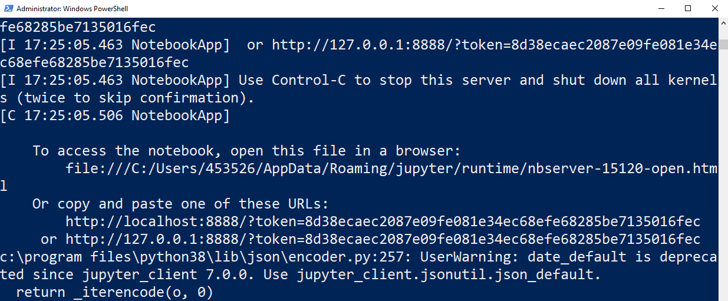

Starting Jupyter Notebook (with Anaconda)


Starting Jupyter Notebook
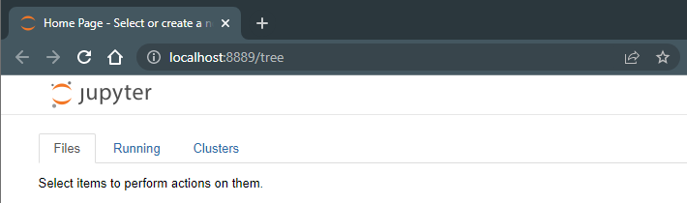

VSCode
- VSCode can also handle .ipynb files
- If you want to use it follow the tutorial here to start working with notebooks.> https://code.visualstudio.com/docs/datascience/jupyter-notebooks
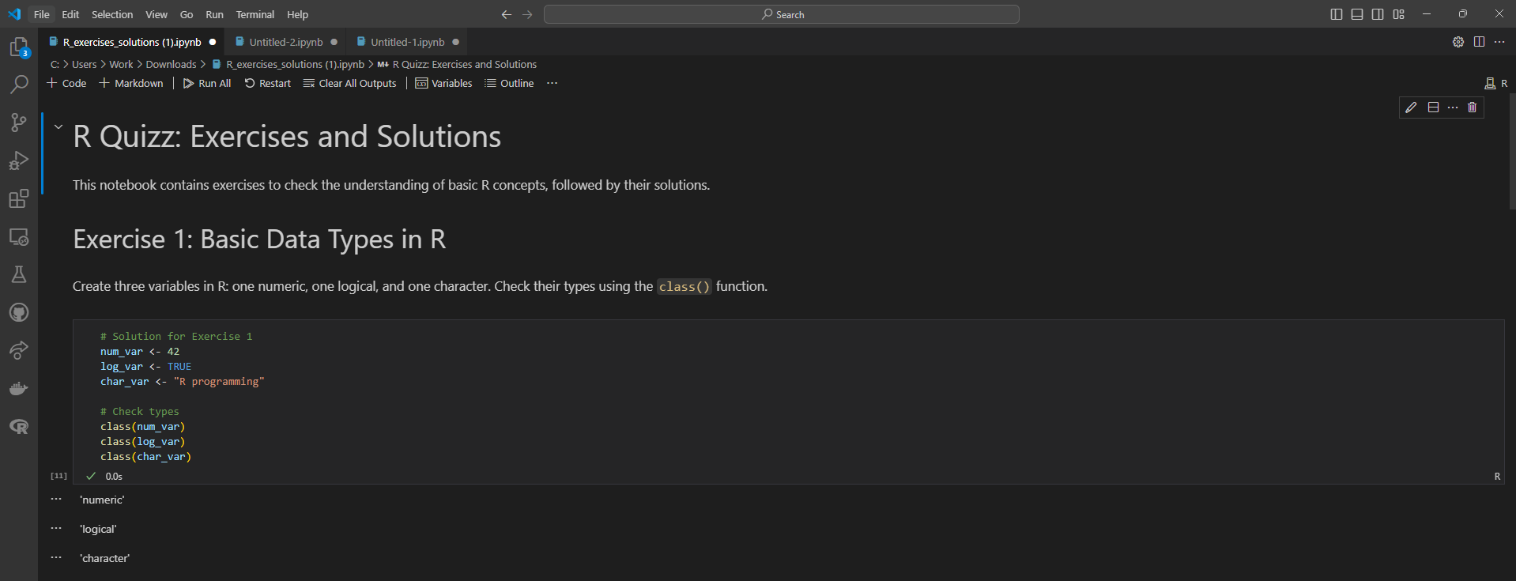

Markdown Cells
- Jupyter notebooks consist of blocks of code (called cells). Each cell can be either code or markdown (dropdown at the top of the screen)
- Jupyter uses GitHub markdown for the text cells.
- Markdown is a simple text-based formatting system
- For a full list of markdown commands see this web-page > https://github.com/adam-p/markdown-here/wiki/Markdown-Cheatsheet
- When you edit a cell you will see the markdown source code, run the cell to see the formatted output

Code cells
- Code cells let you run Python/R code (depending on the chosen kernel) and show you the output directly underneath
- Variables can be shared between cells (provided you run them in the correct order).
- Before submitting a notebook select the option to restart kernel and run all cells to make sure it will work for another user running your notebook (when you’re working ad-hoc it’s easy to get the order wrong)
Eamonn – important below when submitting

Submitting Notebooks – Important!!
- Make sure you run your code before saving your notebook for submission
- If you’re using external files, include them in the notebook folder and use a relative path, for example
  - > I = cv2.imread(‘image.jpg’)
Not
> I = cv2.imread(‘C:\Users\453526\Python\image.jpg’)
- When you’re finished, save the notebook, and zip the entire folder including any external files you used
- Your instructor should be able to restart kernel and run all cells without making any edits

Downloading and Installing R (from scratch)

- R is another base language you’ll be using.
- It is “a free software environment for statistical computing and graphics”. By itself, R is just a programme which will read in and execute a script.
  - Open an internet browser and go to www.r-project.org
    - Times out >>> use https://cran.r-project.org
    - List of mirrors > https://cran.r-project.org/CRAN_mirrors.csv
    - use this >>> https://cloud.r-project.org/
      - It auto re-directs to a working mirror
  - Click the "download R" link in the middle of the page under "Getting Started."
  - Select a CRAN location (a mirror site) and click the corresponding link.
  - Click on the "Download R for Windows" link at the top of the page.
  - Click on the "install R for the first time" link at the top of the page.
  - Click "Download R for Windows" and save the executable file somewhere on your computer. Run the .exe file and follow the installation instructions.
  - Now that R is installed, you need to download and install RStudio.

RStudio (from scratch)

- RStudio is a very nice Integrated Development Environment (IDE) which makes writing R programmes a joy. This isn’t necessary but highly recommended!
  - Go to https://posit.co/download/rstudio-desktop/ and click on the "Download RStudio" button.
  - Click on "Download RStudio Desktop."
  - Click on the version recommended for your system, or the latest Windows version, and save the executable file. Run the .exe file and follow the installation instructions.

R and RStudio (Anaconda)

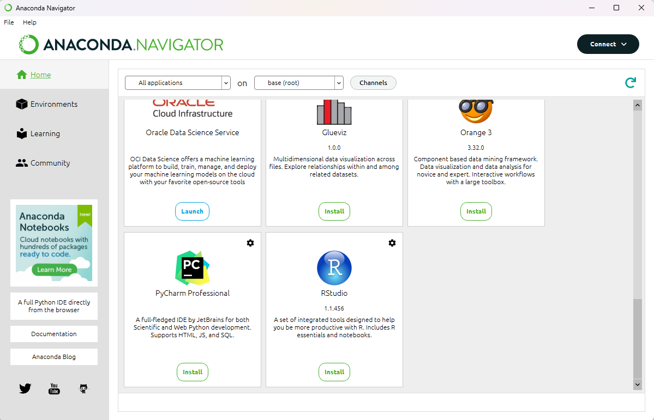

RStudio example

- Download the file “Titanic Exploration.Rmd” in Brightspace and open it with RStudio.
- Rmd is an extension for R Markdown file.
  - It contains YAML (yet another markup language) metadata, Markdown-formatted plain text, and chunks of R code that, when rendered using RStudio, combine to form a sophisticated data analysis document.

Lab

- This week you will go through the same Titanic Exploration example but using Python and Jupyter Notebook instead.
- Download the file “Titanic Exploration.ipynb” in Brightspace and make sure you can run the code in it.
- Check the difference in syntax between Python and R and see what you prefer. Observe the differences between methods and data types to achieve the same results.
- You won’t understand all the details. This is just to give an overview of how and what you can do with both languages.
comments
- Clear the console/terminal in R Studio , This sends a form feed character to the console, effectively clearing it.
  - >>run in the rstudio console >>> cat("\014")
- This will list all installed packages. Look for "languageserver" in the output.
  - installed.packages()[, "Package"]
    - installed.packages() returns a matrix where rows are package names and columns are details (Version, Priority, LibPath, etc.).
    - so you cannot directly use [, "ggplot2"], because "ggplot2" is not a column, it’s a package name (row name).
  - library(languageserver) >>load it > if installed no error
  - packageVersion("languageserver") >> which version
  - "ggplot2" %in% rownames(installed.packages())
  - packageVersion("ggplot2")
- To render the full .Rmd, you still need to run: to run a file
  - rmarkdown::render("your_file.Rmd")
- Pandoc error in VSC when run rmd file
  - > rmarkdown::render("Titanic Exploration - R.Rmd")
  - Error: pandoc version 1.12.3 or higher is required and was not found (see the help page ?rmarkdown::pandoc_ac_available
  - RStudio ships with Pandoc built in, but VS Code does not. That’s why you get the error. >> hence get error above in VSC
  - Quarto include pandoc - so don’t need to install pandoc if have quarto

Notes and example code – taken from Lab 1 file – Titanic Exploration- R.Rmd

Summary
- Performing a summary on the entire dataset is always a good place to start when cleaning data
    - ```{r}
    - summary(data)
    - ```

Convert a data type
    - ```{r}
    - data$Survived <- as.logical(data$Survived)
    - data["Survived.logical"] <- list(NULL)
    - ```

Character data
- is the *R* equivalent to what most programmer's would think of as *strings*
    - ```{r}
    - data$Name <- as.character(data$Name)
    - summary(data$Name)
    - ```

Factor
- Convert the `Name` feature to a **factor**. Thus, when we ask R to give us a summary of the `Name` feature we see a list of all of the unique passenger names, and the number of times each appears in the dataset. This would be very handy for something like *Genre* in a movie collection, as it would allow us to see how many of each type of movie we had, but it doesn't make much sense for Names
    - ```{r}
    - # By passing in maxsum=5 I'm telling R to show me no more than 5 unique values.
    - data$Name <- as.factor(data$Name)
    - summary(data$Name, maxsum=5)
    - ```

Factor Data –
- The **factor** datatype makes much more sense for this feature “sex”
    - ```{r}
    - summary(data$Sex)
    - ```
    - ```{r}
    - data$Sex <- as.factor(data$Sex)
    - summary(data$Sex)
    - ```

Factorign but with Order – i.e. First, second , third
    - ```{r}
    - ?factor
    - ```
  - We can look at the manual for the factor function by typing a question mark into the console followed by the function name. We can see from the output that the `factor()` function allows us to specify both the labels (human-readable text) and the levels (numbers reprenting the ordering between items). Notice that when we want to pass multiple values for `levels` and `labels` we use the `c()` (*combine*) function to combine the values into a single list. By specifying an ordering between the different categories (or to speak in R's language, **levels**) we allow R to be more intelligent when displaying graphs *etc.*
    - ```{r}
    - data$Pclass.factor <- factor(data$Pclass,
    - order=TRUE,
    - levels=c(1.0,2.0,3.0),
    - labels=c("1st Class", "2nd Class", "3rd Class")
    - )
    - ```

Integer and Numeric Data
  - Integer and Numeric Data
  - Summary of ‘age” feature in file
    - ```{r}
    - summary(data$Age)
    - ```
  - Age has been recognised as a number. Notice, however, that the youngest passenger is 0.42 years old. This is strange. And it looks like the majority of ages are simply specified to the year.
  - We can use the [modulus (%%) operator](https://en.wikipedia.org/wiki/Modulo_operation) to to remove everything to the left of the decimal point The statement `12 %% 5` instructs R to divide 12 by 5 and return only the remainder
  - If we convert the `Age` feature to a **factor**, then *R* will keep track of each unique value for us. If we summarize the data *as a factor* we'll get a breakdown of each of the distinct values. Notice that even though we're converting `data$Age` to a factor we're not assigning the result back to our table so our data is left unchanged
    - ```{r}
    - summary(as.factor(data$Age %% 1))
    - ```
  - We can see 25 ages have been specified to at least 1 decimal place and 862 have not. This looks like inconsistency in data collection. We can simply remove the decimal place to fix this, effectively rounding everything down.
    - ```{r}
    - data$Age <- as.integer(data$Age)
    - ```

Visualising the Data

Histograms
- histogram takes a numeric variable on the x axis, groups similar values together into *bins*,
- ggplot to put Age on the X axis, andrepresent whether or not a passenger survived by colour (fill). We're then specifying that we want it to create a histogram for us, and finally, we're using the `labs()` (labels) function to specify a title for the graph.
  - ```{r}
  - ggplot(data, aes(x=Age, fill=Survived)) +
  - geom_histogram() +
  - labs(title="Survival Rate by Age")
  - ```
- Notice the warning message from R in the console. We didn't tell R how
- wide we want our bins to be. so it's defaulted to using 30 bins.
- For Loop
  - For Loop to change bin width
    - ```{r fig.height=1.75, fig.width=3.5}
    - # This for loop is telling R to create this plot with different binwidths.
    - # 1:10 is a shorthand way of writing c(1,2,3,4,5,6,7,8,9,10)
    - for (binwidth in 1:10) {
    - # Because we're inside a for loop, we now need to explicitly tell ggplot
    - # to draw our plot by using the print() function
    - print(ggplot(data, aes(x=Age, fill=Survived)) +
    - geom_histogram(binwidth=binwidth) +
    - labs(title=paste("Survival Rate by Age, Binwidth", binwidth)))
    - }
    - ```
  - Narrower bins give more precise visualizations but if they're too narrow they just add noise to the graph. Pick a bin-width that shows an interesting trend without being too noisy (random ups and downs)

Bar Charts
- Visualize counts of data broken down by category.
- The `scale_fill_discrete` function allows us to control the way fill is used within the graph. By passing explicit values for labels we can change the legend text. Also, by adding `position="dodge"` to the `geom_bar` function we tell R to make the bars sit beside (rather than on top of) one another.
    - ```{r}
    - ggplot(data, aes(x=Sex, fill=Survived)) +
    - geom_bar(position="dodge") +
    - scale_fill_discrete(name = "Outcome", labels = c("Did Not Survive", "Survived")) +
    - labs(title="Passenger Survival by Gender")
    - ```

Faceting
- A way to split a dataset into subsets and draw separate plots for each subset, arranged in a grid
- Facets allow you to combine multiple graphs filtered on one or more categories, or **factors**.
- To see how Age, Passenger Class and Gender interacted to influence survival. We start by defining a single histogram plot which shows how the survival rate varied with age. We're going to repeat this plot for each combination of class and gender. The facet_grid function allows us to specify which variables we'd like to split our data on.
    - ```{r}
    - # Make sure you've loaded the `lattice` module
    - # We did this with our library(lattice) at the top of the script

    - ggplot(data, aes(x=Age, fill=Survived)) +
    - geom_histogram(binwidth = 5) +
    - facet_grid(Sex ~ Pclass) +
    - ggtitle("Titanic Survival by Age, Gender and Class")
    - ```

Computed Features
- Categorize our passengers into children and adults. By using the dollar operator we're creating a new feature on our dataset called `IsChild`. `IsChild` will be true if `Age` is less than 16, false otherwise. Create that value and plot it….
    - ```{r}
    - data$IsChild <- data$Age < 16

    - ggplot(data, aes(x=IsChild, fill=Survived)) +
    - geom_bar(position="dodge") +
    - scale_x_discrete(name="Child/Adult", labels=c("Adult", "Child")) +
    - scale_fill_discrete(name = "Outcome", labels = c("Did Not Survive", "Survived")) +
    - labs(title="Titanic Survival Rate of Adults/Children")

    - ```

Formula
- The tilde (\~) operator in R denotes a formula. We can read the example below as 'Sex' by 'Class' Try it out and then see what happens if you swap the formula around

Python vs R
- .Rmd > extension for R markdown file
  - Contains yaml metadata
  - Chunks of R code
- Ipynb
  - Convert t Boolean using astype method
  - Iloc = method to returna slice of the dataframe
    - `df.iloc[:,0]`
    - Gives all the rows and first column only.
  - df.iloc[:,0] = df.iloc[:,0].astype(bool)
  - df.describe(include="all")
  - set ‘Age’ to be an integer ‘int64’ using astype =? No more decimals
    - df["Age"] = df["Age"].astype('int64')

iloc index based selection vs column name
Feature | df["Age"] = ... | df.iloc[:, 0] = ...
Access type | Label-based | Position-based
Readability | ✅ clear | ❌ ambiguous
Safe against column reorder | ✅ yes | ❌ no
Use case | When you know the column name | When writing generic code or using column index
Typical usage | df["Age"] = df["Age"].astype(int) | for i in range(df.shape[1]): df.iloc[:, i] = ...

- Summary (R) vs describe (python)
  - what happens if you remove the `include="all"
  - df.describe(include="all")
  - describe only sumarises numeric columns…
  - summarizes all columns, regardless of type (numeric, categorical, object, datetime, boolean, etc
  - Both summary() (R) and describe() (pandas) give quick dataset overviews, but they behave a bit differently.
  - Summary >>

Feature | R: summary() | Python: df.describe()
Default scope | All columns | Only numeric
Numeric stats | Min, 1Q, Median, Mean, 3Q, Max | count, mean, std, min, 25%, 50%, 75%, max
Categorical | Shows full frequency table | Only unique, top, freq
Output format | Human-readable, per column | Tabular (matrix-like)
Extensibility | Works on many object types (lm, glm, etc.) | Mostly for DataFrames/Series

Visualization
- Histogram
  - plot an histogram of *Age* separated by *Sex*. For that we will need to use the `pivot` method to get only the data we are interested in plotting, or in this case the *Age* feature separated by females and males.
  - using the `plot` method of the Pandas module.
    - df.pivot(columns="Sex", values="Age").plot.hist(bins=30, stacked=True)
  - histogram with different binwidths
    - In Python we can do that by passing the number of bins or a sequence representing the bin edges. In this example we are going to use the sequence option.
  - Generate a sequence we are going to use the `range` function from the built-in Python functions. Its header is defined as `range(start, stop, step)`, so given a start and stop values it creates all the numbers in the sequence between them with step `step`. For example `range(0, 12, 2)` will generate the sequence `0, 2, 4, 6, 8, 10`
  - It uses a **for** loop to generate sequences of bin edges with different steps

    - for binwidth in range(1,10):
    - df.pivot(columns="Sex", values="Age").plot.hist(bins=range(min(df["Age"]), max(df["Age"]) + binwidth, binwidth), stacked=True)
- Barcharts
  - first we add the axes to the figure, then we add one bar, then the legend, etc. It offers a lot of customisation, allowing us to define how the graph will look in detail.
  - # plt refers to the `matplotlib.pyplot` module that
  - # we imported in the first cell. Here we are creating a figure
  - # with the figure method.
  - fig = plt.figure()

  - # Add axes with the add_axes method to the figure object.
  - # This defines the dimensions [left, bottom, width, height] of the
  - # new axes as fractions of figure width and height. It does not
  - # define the actual size of the figure. Here, left and bottom are at (0,0)
  - # and width and height have proportion 1 to the figure size, so it is a square.
  - # Try changing the third value to 0.5 and see what happens.
  - ax = fig.add_axes([0,0,1,1])

  - # First, we filter the data according to the criteria we want, i.e. male and survived.
  - # To filter, we are applying some conditionals to the Pandas dataframe.
  - female_died = df[(df.Sex == "female") & (df.Survived == False)]
  - female_survived = df[(df.Sex == "female") & (df.Survived == True)]
  - male_died = df[(df.Sex == "male") & (df.Survived == False)]
  - male_survived = df[(df.Sex == "male") & (df.Survived == True)]

  - # To count, we are using the `len` (short for length) method of Python.
  - # The code below starts by adding two bars to the axes using the bar method and
  - # associating to each bar the data we want to plot.
  - # It follows then by adding the legend, title, y label, x ticks, and x ticklabes.
  - # Finally, once we have defined everything we are calling `plt.show` to plot the graph.
  - # Try to investigate the code below and see what it does.
  - # Perhaps run some smaller parts in different cells and see how they work.
  - ax.bar([0, 1], [len(female_died), len(male_died)], color = 'b', width = 0.25,)
  - ax.bar([0.25, 1.25], [len(female_survived), len(male_survived)], color = 'r', width = 0.25,)
  - ax.legend(labels=['Did not survive', 'Survived'])
  - ax.set_title('Passenger survival by gender')
  - ax.set_ylabel('Count')
  - ax.set_xticks([0.125, 1.125])
  - ax.set_xticklabels(["Female", "Male"])
  - plt.show()
- Facets
  - Same as in R
  - we are going to use the `subplot` method of `matplotlib` that allows us to plot multiple graphs in a single figure. To filter the data according to the combination of features we are interested in, we are running two nested loops that will iterate over the values of *sex* and *pclass*. Note that this time we are actually defining the figure sizes before plotting them. S

    - sex = ["female", "male"]
    - pclass = [1, 2, 3]
    - index = 1
    - nrows = 1
    - ncolumns = 6

    - plt.figure(figsize=(50, 10))

    - for p in pclass:
    - for s in sex:
    - plt.subplot(nrows, ncolumns, index)

    - data = df[(df.Sex == s) & (df.Pclass == p) & (df.Survived == False)].Age.values
    - plt.hist(data, bins=range(min(data), max(data) + 5, 5))

    - data = df[(df.Sex == s) & (df.Pclass == p) & (df.Survived == True)].Age.values

    - plt.hist(data, bins=range(min(data), max(data) + 5, 5))

    - plt.legend(labels=['Did not survive', 'Survived'])
    - plt.title(s + " " + str(p) + " class")
    - plt.xlabel("Age")
    - plt.ylabel("Count")
    - index += 1

    - plt.tight_layout()
    - plt.show()

Questions?

Week 2 – Review Python and practice

Indicative schedule

Week 1 | Set up environment and R notebook
Week 2 | Review Python and practice
Week 3 | Review R, importing data
Week 4 | Intro SQL and aggregate queries
Week 5 | Databases and scripting languages (To be submitted)
Week 6 | Interpreting Data (summary statistics, data visualisation)
Week 7 | Review week
Week 8 | Data manipulation in R
 | Pandas and Numpy
Week 9 | Data visualisation in Python
 | Data processing (regular expressions)
Week 10 | Audio data (R and tuneR) (To be submitted)
Week 11 | Image data (Python and skimage) (To be submitted)
Week 12 | Time series (Python and Pandas)
Week 13 | Working on Assignment
 | Assignment deadline

Overview

- Python
  - Data types
  - Functions
  - Lists
  - Sets
  - Dictionaries
  - Tuples
  - Strings

Before you start
- You should be familiar with at least one general-purpose language
  - Functions / Methods
  - Flow-Control (if/else and loops)
  - Variables
  - Types
- We are going to see a very quick introduction. More training is available on the datacamps provided.
  - Intro to Python for Data Science
  - Intermediate Python

Datacamp 

- You can access DataCamp courses for extra practice (that is highly recommended)
- Please create an account with the @mytudublin.ie domain to have free access to all courses through the link below
Link to register on DataCamp
- Some courses that might help you in the first weeks (not all there is covered in this module):
Intro to Python for Data Science
Intermediate Python
Introduction to R
Introduction to importing data to R
Web scraping in R

Eamonn: comment to do datacamp courses to get up to speed

Data Types

Python Built-in Data Types
- Integer: Whole numbers (can’t contain decimals)
- Float: Any number (can contain decimals)
- Boolean: Either True or False
- String: Text
- List: A collection of values arranged one after the other
- Set: A collection of values with no duplicates
- Dictionary: A collection of values which can be accessed with lookups
  - Comment > (also known as associative arrays or has maps in other languages)
- Tuple: Similar to a list, but with a fixed size and order
  - Comment > same as lists but immutable and can’t be changed

Checking and Converting Types

- Usually you don’t need to worry about data types.
  - Comment > don’t need to specify when creating… that’s good and bad…
  - Comment > As we don’t types python as “introspection”
  - Comment > Opens possibilities – we can create functions based on type in the arguments
    - In java have to clearly specify
- If you need to check you can use the type() function
- This is called introspection, meaning that a variable might change its type, and you can check that during runtime.
- Comment > Python is Object orientated
- Comment > we wont’ be using classes in this course tho

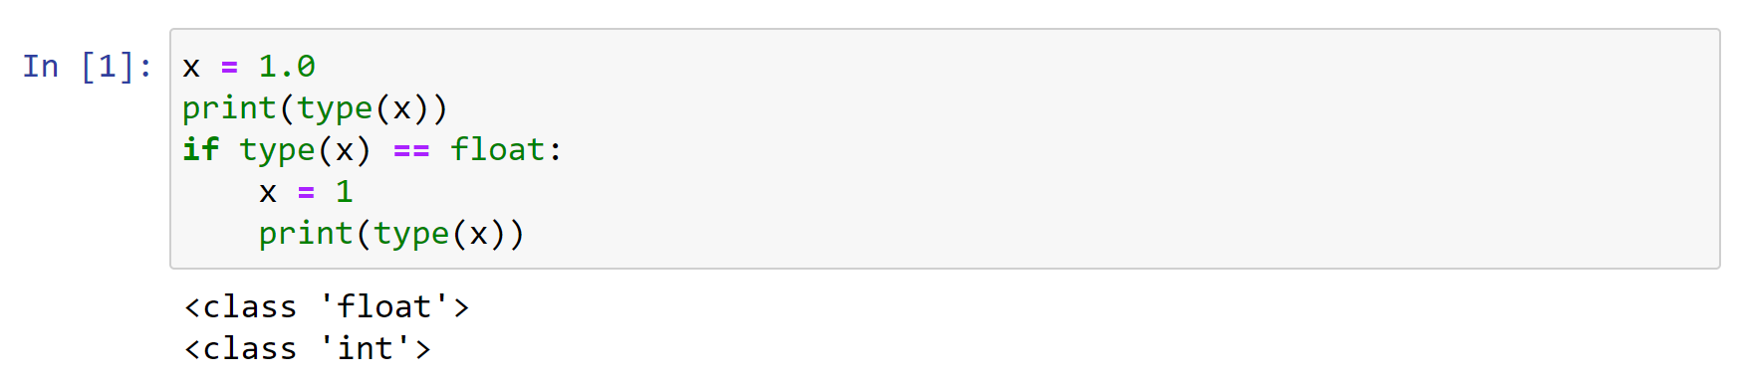

Functions

Python functions
- Comment > Is A function like in any other language
- A Python function is a block of code that returns something and that we can run later in the script
- It allows us to reuse code
- Functions can take zero or more parameters

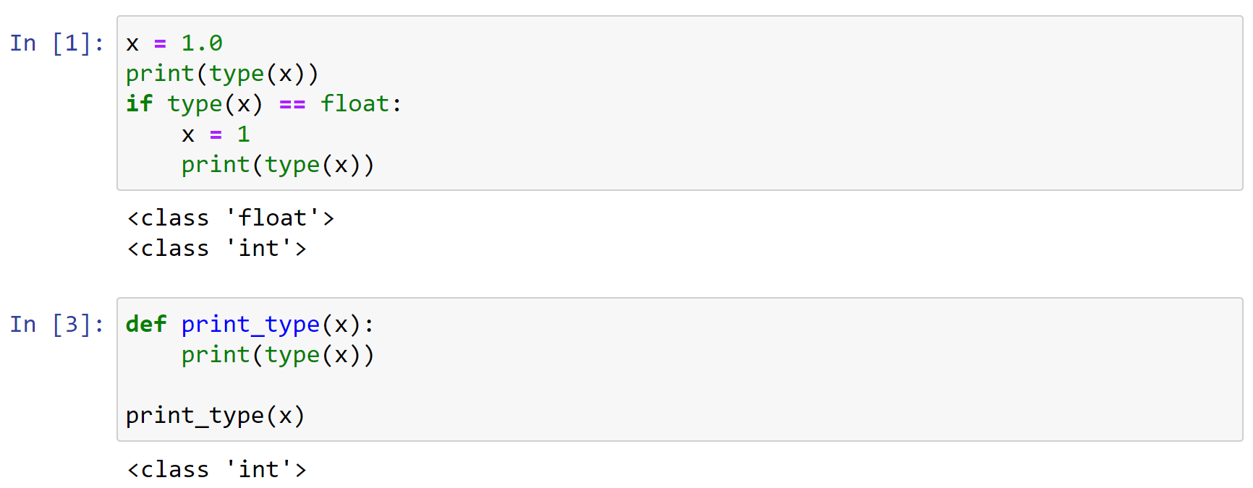

‘’’ py
x = 1.0
print(type(x))

if type(x) == float:
x=1
print(type(x))

def print_type(x):
print(type(x))

print_type(x)
‘’’
‘’’py
Comment >> can annotate to specific a type. We want two floats but we cannot enforce that….
>> comment : Also indicate we want to eturn a float, but we can’t enforce and still works witn ints
def add_values(a: float, b: float) -> float:
return a + b
def print_type((x: int))
print(type(x))

x= 1
print_type(x)
print(add_values(5, 4))

- comment >>> repeat with strings >>> works and concatenates >>> only works because of introspection i.e. we cannot force the type
- if int pr float => ads
- if str => concatenates
- (checks type before does work)
- If do for mixed tupe i.e. str and in => get error as can’t add str and int/float

x= 1
print_type(x)
print(add_values(“5”, “4”))

‘’’

Python functions
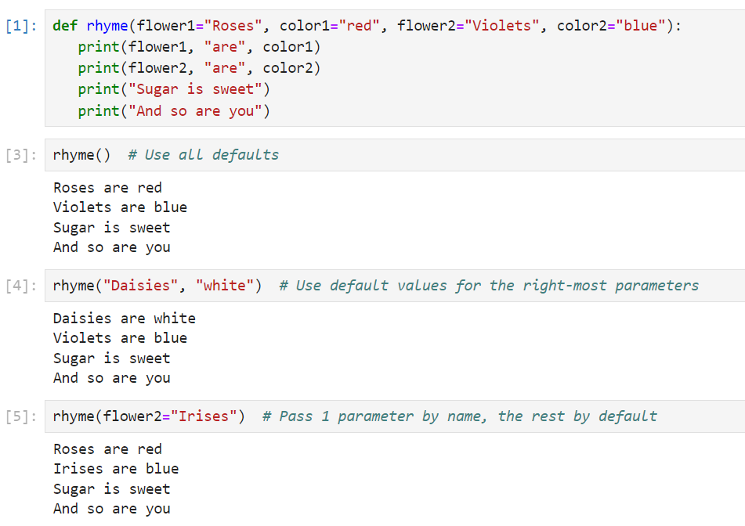
‘’’py
Def rhyme (flower1=”Ross”, color1=”Red”, flower2=”violets”, color2=”blue”)
Print(flower1, “are”, color1)
Print(flower2, “are”, color2)
Print(“sugar is sweet”)
Print(and so are you”)

rhyme()

‘’’

Comment > different ways tp pass a parameter in python > will sue a lot of functions

Lists

What is a Python List?
- A list lets us pack lots of values into a single variable
- Similar to an array in most other languages
- We can use loops to process each item in an array
- Or we can retrieve items individually by index
- Python allows you to store different data types in a single list

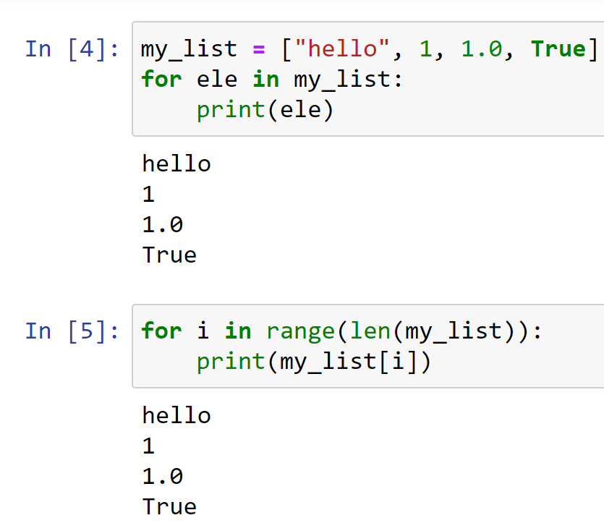

‘’’py
my_list = ["hello", 1, 1.0, True]

for ele in my_list:
print(ele)

for i in range(len(my_list)):
print(my_list[i])

my_list.append("banana")
print (my_list)

my_list.remove("banana")

‘’’

Working with Lists

- We can create a list in Python using square-bracket notation
- We can add items to the end of a list using the list append() method
- We can remove items using the remove() method
  - This removes the first occurrence only
  - If the item doesn’t exist in the list we get an error

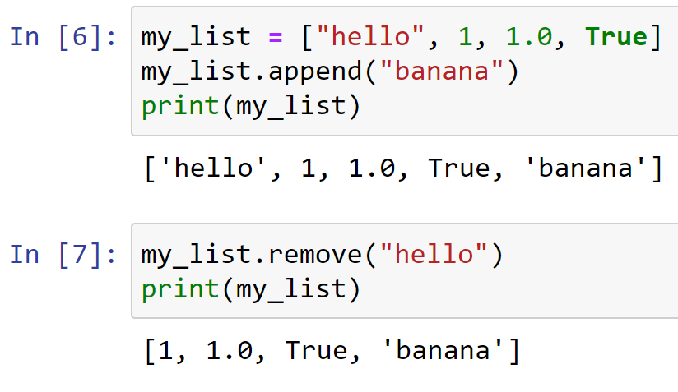

Accessing Items by Index

- Each item in a list has an index, or position, within the list
- Python indexes are zero-based
  - This means the first item has an index of 0
  - The second item has an index of 1
- We can use the index to retrieve an item from a list

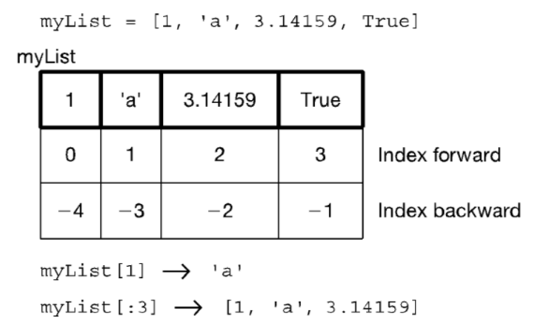

Inserting Items
- We can insert an item in a specific position using the list insert() method.
- 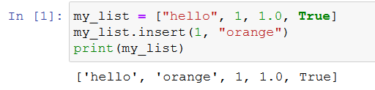
- Or add something in the last position using append()

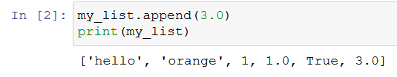
- Comment >
- can add two lists and it appends second list , can multiply a list also get trbles lists etc
- Result not stored any where > just shown on screen when sue print
- Check how big using “len”
- Use “in “ to see fi somethgin in the lisr

if “hello” in double_list
print
‘’’

List operators

- Concatenate +
- Repeat *
- Indexing the [ ] operator
- Slicing [start:end:step] (end not inclusive)
- Membership (the in operator)
- Length len (the length operator)

Lists of lists

What is the second element (index 1) of that list? Another list.
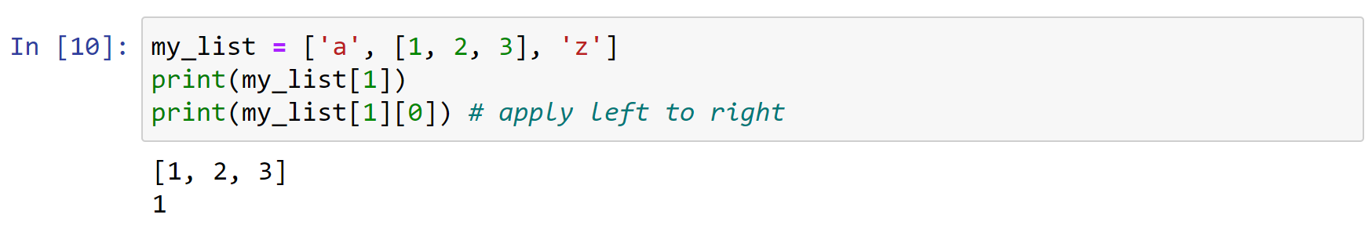

Some list methods
- A list is mutable and can change
  - my_list[0] = 'a' #index assignment
  - my_list.append()
  - my_list.extend()
  - my_list.pop()
  - my_list.insert()
  - my_list.remove()
  - my_list.sort()
  - my_list.reverse()
- Python documentation:
  - https://docs.python.org/3.1/tutorial/datastructures.html

List comprehension

- List comprehensions are a very readable way of creating lists (once you get used to them)
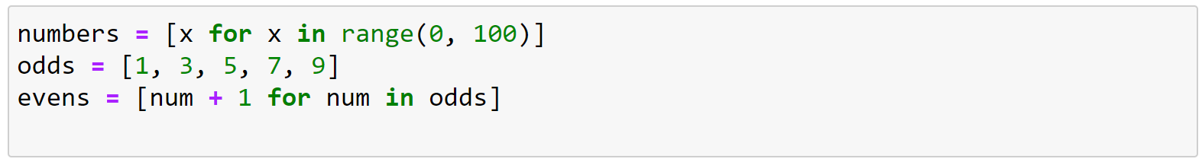
- Comment >
- short way to create list in python
- Can add condition to end i.e. if % 2 == 0 (if value of x is even….) add it to the list
- Can add some operation to the value we are collecting x + 1 ( now even list becomes odd list
- Can use for tuple and dictionaries aswell… not just lists
- Read it from the RHS!!!

‘’’py
# list comprehensions
numbers = []

for x in range(0,100):
numbers.append(x)

print(numbers)

numbers = [x for x in range(0,100) if x % 2 == 0]
print(numbers)

numbers = x+1 for x in range(0,100) if x % 2 == 0)

numbers = [x for x in range(0,100)]
odds = [1, 3, 5. 7, 9]
evens [num + 1 for num in odds]
‘’’

Sorting Lists
- We can use the list sort() method to sort a list in ascending order
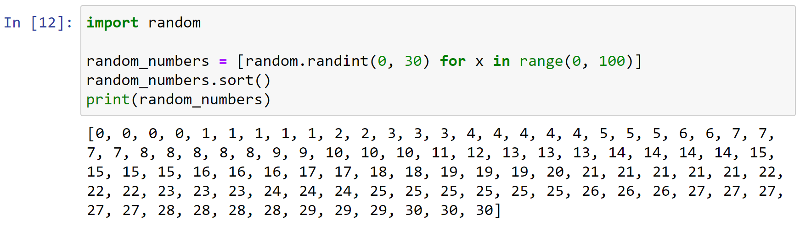

‘’’py
Import random
random_number = [random.randint(0,30) for x in range(0,100)]
random_numbers.sort()
print(randome_numbers)

‘’’

Tuples

- Tuples are immutable sequences
- They are printed with (,) and similarly to lists can have various length
- Comment >
- same as lists except immutable - -i.e. cannot be changed…
- We know it’s a tuple because it has no brackets and there is a comma
  - This is a tuple with two values… (below
  - Access same as with lists….
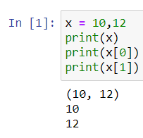
- Not a tuple, multiple assignment
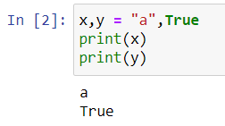

- For the most part, tuples work exactly like lists
- However, an immutable list gives you a data structure with some integrity, some permanent-ness if you will
- You know you cannot accidentally change one.

Tuples – 2
- Everything that works with a list works with a tuple except methods that modify the tuple
- Thus indexing, slicing, len, print all work as expected
- However, none of the mutable methods work: append, extend, del

- For tuples you can think of a comma as the operator that makes a tuple, where the ( ) simply acts as a grouping:

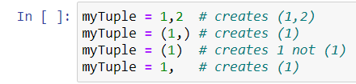

- Suppose my_tuple = (1,2,3,4,5)
  - Concatenate: my_tuple + my_tuple
  - Repetition: my_tuple * 3
  - Index access: my_tuple[1]
  - Index access: my_tuple[-1]
  - Slice: my_tuple[:3]
  - Slice: my_tuple[1:3]
  - Membership: 2 in my_tuple
  - Membership: 10 in my_tuple
  - Length: len(my_tuple)
  - Minimum: min(my_tuple)
  - Maximum: max(my_tuple)
  - Sum: sum(my_tuple)
  - Comparison: (1,2,3) > (1,2,1)

/’’’ py
Is one tuple greater than another / checks values individually, 1 vs 1 , 2 vs 2 , 3 vs 2)

Print(1, 2, 3) > (1, 2, 2)
TRUe

‘’’’’

Sets

Python Sets
- A python set is similar to a list but
- Sets cannot contain any duplicates
- Sets are unordered (no index)
- Sets follow the rules for mathematical Set Theory
  - https://www.probabilitycourse.com/chapter1/1_2_0_review_set_theory.php
- Checking if an item exists in a set is very fast

- Comment
  - To find intersection
  - Union etc
  - Very fast to check if item tina set
  - Cn create set from anythgin caniterate over
  - Curly braces =>> a set
  - Can create with dups but wil only keep unique values
  - To find unique avleus in a list or tuple >>> create a set out of it and will get al unique elements
  - Move to sets and use intersectin method
  - Use sets for their methods…. In / not in / union / intersetction / difference / symmetric.difference (union minus the intersection)
  - .differemce >>> elements in set 1 not in set 2 >> order matters difference between which set and which…

Creating a set
- Sets can be created in one of two ways:
  - constructor: set(iterable) where the argument is iterable
my_set = set('abc')
print(my_set) 🡪 {'a', 'b', 'c'}
  - shortcut: {}, curly brackets where the elements have no colons
my_set = {'a', 'b','c'}
- Duplicates are automatically removed
my_set = set("aabbccdd")
print(my_set) 🡪 {'a', 'c', 'b', 'd'}

Set Operations
- len(s) → Number of elements in the set
- x in s → test if set s contains value x
- x not in s → the opposite of x in s
- s.union(t) → new set with everything in s and everything in t
- s.intersection(t) → new set containing elements in both s and t
- s.difference(t) → new set with elements in s but not t
- s.symmetric_difference(t) → new set with elements in s or t but not both

Check yourself

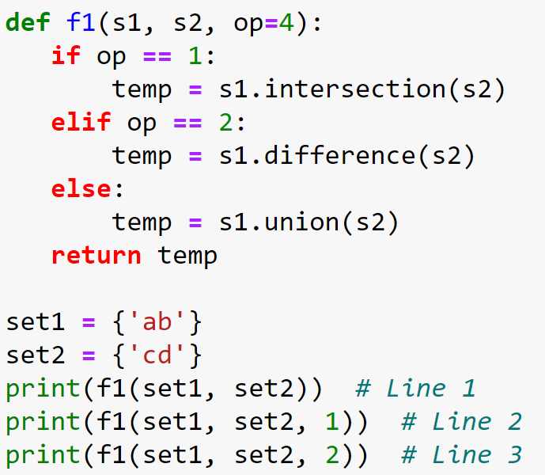

Q: What is the output of (a) Line 1, (b) Line 2, and (c) Line 3

‘’’py
def f1(s1, s2, op=4):
if op==1:
temp = s1.intersection(s2)
elif op==2:
temp = s1.difference(s2)
else:
temp = s1.union(s2)
return temp

set1=(set('ab'))
set2= set('cd')
print(f1(set1, set2))
print(f1(set1, set2, 1))
print(f1(set1, set2, 2))

‘’’’’

Dictionaries

Python Dictionaries

- In data structure terms, a dictionary is better termed an associative array, associative list or a map.
- You can think if it as a list of pairs, where the first element of the pair, the key, is used to retrieve the second element, the value.
- Thus we map a key to a value
- Use the { } marker to create a dictionary. Use the : marker to indicate key:value pairs. Separate elements by comma.
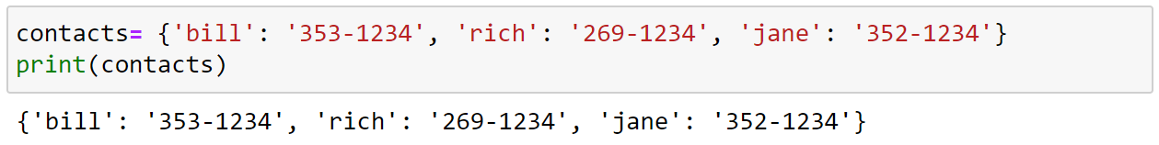

- Key must be immutable
  - strings, integers, tuples are fine
  - lists are NOT
  - cannot have repeated keys
  - need to eb unique so we can access the value…
  - key can be a tuple….strings/int
  - keys are collections
- Value can be anything
- Keys can not be repeated in the dictionary
- Dictionaries are collections but they are not sequences (such as lists, strings or tuples)
- There is no order to the elements of a dictionary
  - in fact, the order (for example, when printed) might change as elements are added or deleted
comments

‘’’ py

‘’’’

Dictionary operations
- Comment
- Good to know operations!!!

- key in d: returns True if the item is found, False otherwise
- d.get(key, [default value]): gets the item with the given key. If the key doesn't exist this will return default value, if you've given one, otherwise it will error
- d[k] = v: adds v to the dictionary with the key k
- d.keys(): returns the set of all keys in the dictionary d
- d.values(): returns a list of all values in the dictionary d
- d.items(): returns a list of all key-value pairs in the dictionary d
- del d[k]: removes the item with key k from the dictionary

- comment
- we know it’s a dict because of curly bracktes and colon…

Looping through a Dictionary

- We can loop through a dictionary just like we can loop through a list
- The keys() method returns all of the keys in the dictionary
- The values() method returns all of the values in the dictionary
- The items() method returns both keys and values for the dictionary

Looping through a Dictionary – 2

‘’’py

Contacts = {'bill': '333-1234', 'rich' : '269-345', 'jane': '5423-2345'}
print(Contacts)

for key in Contacts:
print(key)

for key, value in Contacts.items():
print(key, value)

for value in Contacts.values():
print(value)

‘’’
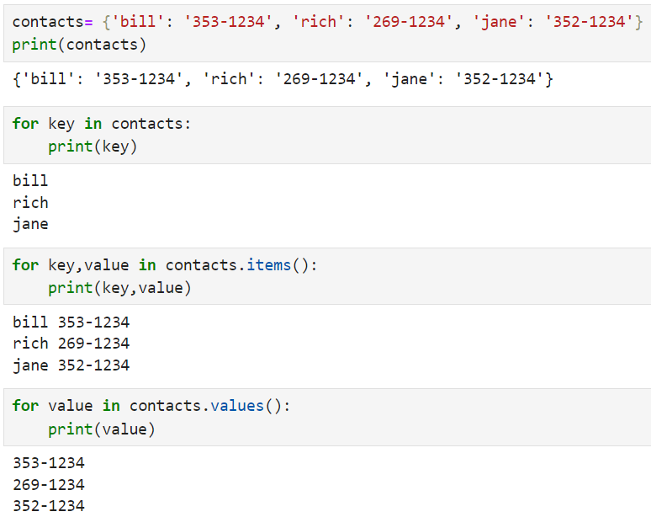

Check yourself
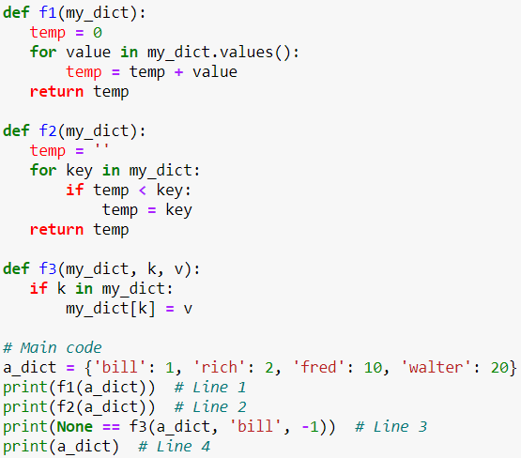

Question : What is the output of (a) Line 1, (b) Line 2, (c) Line 3, and (d) Line 4?

‘’’py
def f1(my_dict):
temp=0
for value in my_dict.values():
temp = temp + value
return temp

def f2(my_dict):
temp=''
for key in my_dict:
if temp < key:
temp=key
return temp

def f3(my_dict, k, v):
if k in my_dict:
my_dict[k] = v

# main
a_dict={'bill': 1, 'rich': 2, 'fred': 10, 'walter':20}
print(f1(a_dict)) # Line 1 >>> answer adds them up >> 33
print(f2(a_dict)) # Line 2 >> answer >>> empty string is shorter than Bill >> then check 2nd one >> Bill smaller than rich >> B is smaller than R >>>> Rich smaller than Walter it is >>>
all string s with letters… greatest one is walter as no name after “W”
print(None == f3(a_dict, 'bill', -1)) #Line 3 >> not returngin anything >> no key word “return” >> if not return word “None”…
is a side effect of F3 >> passing a dictionry >> check si K is in dict?>> then assign value of Bill to be -1…so before we had Bill1 >>> now it = -1 >>>
print(a_dict) # Line 4 >> answer >>> Bill : -1 >> reason to change and reason not to change >>>> not change thinking these operations not reflect on main scope…. When passing a dict we’re apssing a reference >> when we do this kind of operation here we are changing a value…

mutable change > without changgin associaraion it changes…. Don’t [ass by reference / copy
Passing lists in dicts if passing mutable changes in functinos this will also be reflected outside of the function…

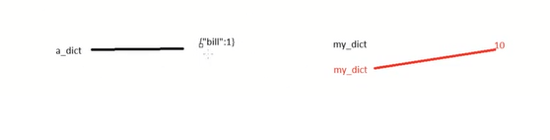

‘’’

Strings

Strings
- A string is a sequence of characters
- In Python it is enclosed between ' ' or '' ''
- The exact sequence of characters is maintained
"Hello" or 'Hello' - OK
"Hello' - Error! >> not a string mixed brackets
- Comment >
- same as a list except all characters
- Strings are immutable

String Access

- Essentially a string is a list of characters, so you can access a string by index
- As with lists, slices and negative indexes work on strings

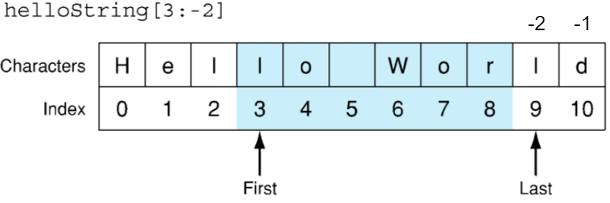

String methods

- We can convert strings to lower and upper case using the upper() and lower() functions
- We can search for text within a string using the string find() method
- We can replace text within a string using the replace() method

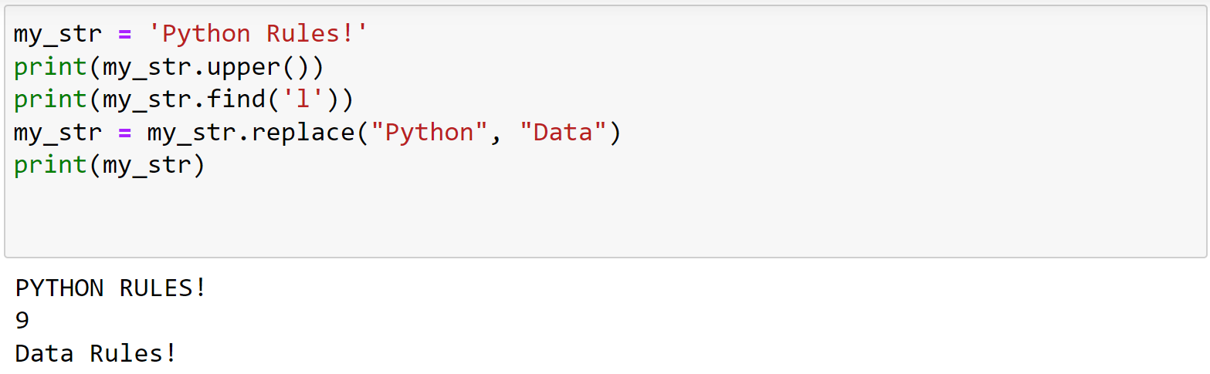
- Comment
- List.append > changes list
- But
- Str.Upper doesn’t change the string value…
- Returns a str that ahs replaced the value…

Split and join

- The split() function converts a string to a list using a specified delimiter
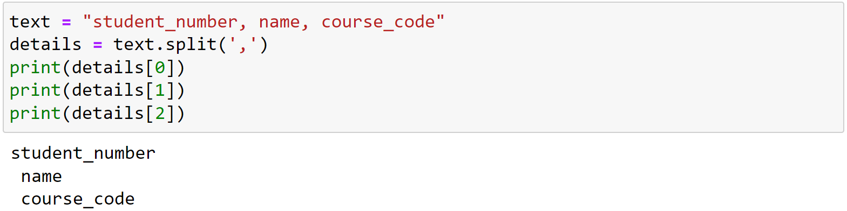
- The join() function converts a list to a string using a specified delimiter

- Comment >>>
- Common for csv file
- Split will return a list
- Can join back using join method in strings…
- Very common in csv >> split > loop over values > join back

‘’’py
text = "standard_number, name, record"
print(text)
details = text.split(",")
print(details)
details.sort()
print(details)
text=','.join(details)
print(text)

‘’’

Advanced String Manipulation

- String manipulation is very important, particularly in Natural Language Processing
- Regular Expressions (RegEx) is a mini-language used for advanced string matching and replacing
- Comment >> on wekk 9 >> regex
- Text Preprocessing is very important in NLP and Python provides lots of libraries to help you do it.
- Comment >> probably need a course just on NLP
- All of this is for another day though!

Summary

- Python
  - Data types description
  - Function syntax and how to create
  - Lists
    - How to create, access, loop through it, remove items, list operators, list methods
  - Sets
    - How to create and methods
  - Dictionaries
    - How to create, access keys and values, loop through it
  - Tuples
    - How to create, operators and methods
  - Strings
    - How to create, access and use some of its methods
- Next week: R data structures and data importation

Questions?

Lab
- Python practice exercises in Jupyter Notebook

Week 3 - Review R, importing data

Last Week
- Python introduction/review
- Any questions?

Overview
- Introduction to R
  - Data Types
  - Vectors
  - Data Frames
- Importing data to R

R in Anaconda

R kernel on Jupyter notebook (no Anaconda)

- Open a terminal and start R or work on the R console in RStudio
- Run
  - install.packages('IRkernel')
  - IRkernel::installspec()
- Restart Jupyter (if running)

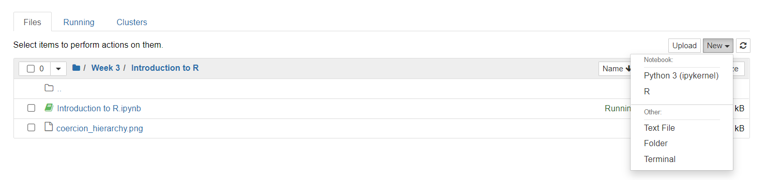

R kernel on Jupyter notebook (with Anaconda)
- Open the command prompt from the navigator
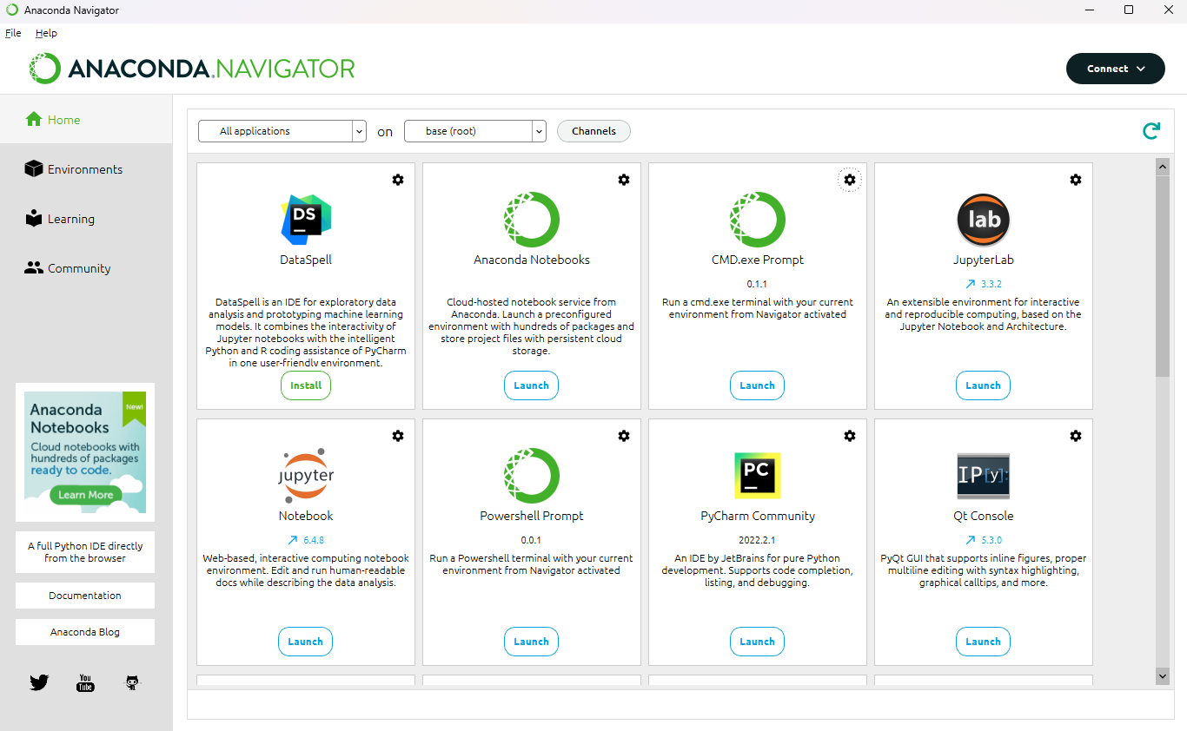

R kernel on Jupyter notebook (with Anaconda)
- Run the conda install command and follow any instructions in the prompt:
conda install -c conda-forge r-irkernel
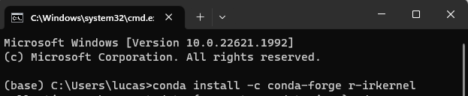
- Any issues check here
https://anaconda.org/conda-forge/r-irkernel

R introduction in the notebook

- Review the notebook available in Brightspace
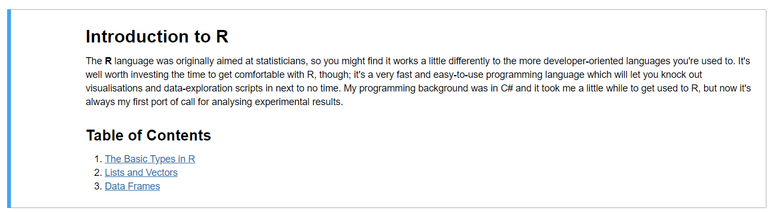

R Quizz

1
Q: Create three variables in R: one numeric, one logical, and one character. Check their types using the `class()` function.

2

Q: Convert a numeric value to an integer and a character type. Observe and explain what happens when you try to perform mathematical operations on each type.

3
Q: Create a numeric vector with both integer and double values. Use the `typeof()` function to determine the type of each element in the vector.

4

Q: Create a vector containing the numbers from 1 to 10. Write R code to calculate the sum, mean, and standard deviation of the vector.

5

Q: Create a list containing at least one element of each basic data type (numeric, logical, character). Access and print the second element of the list.

6
Q: Write a function in R that takes a vector as input and returns a list with the following components: the length of the vector, the sum of its elements, and the product of its elements.

7

Q: Create a data frame with three columns: Name (character), Age (numeric), and IsStudent (logical). Add at least five rows of data.

8

Q: Write R code to add a new column to the data frame created in Exercise 7, which calculates the age of each person in months.

9

Q: Use the `subset()` function to filter the data frame for rows where `IsStudent` is `TRUE`.

Importing Data to R

- Text file formats often use delimiters to separate the different elements in a line
- The most common format is comma separated values (csv)
- However, any character (or sequence of characters) may be used
- The extension sometimes gives additional information (.tsv = tab, .csv = comma)
Lucas,Rizzo,d12345678 (comma separated)
Lucas Rizzo d12345678 (tab separated)

Creating CSV Files
- CSV files can be created with any text editor.
  - If your text editor does not save as csv files, just change their extension to .csv
- Applications such as Excel also allow you to create CSV files
- CSV files are useful because they're portable and simple to work with
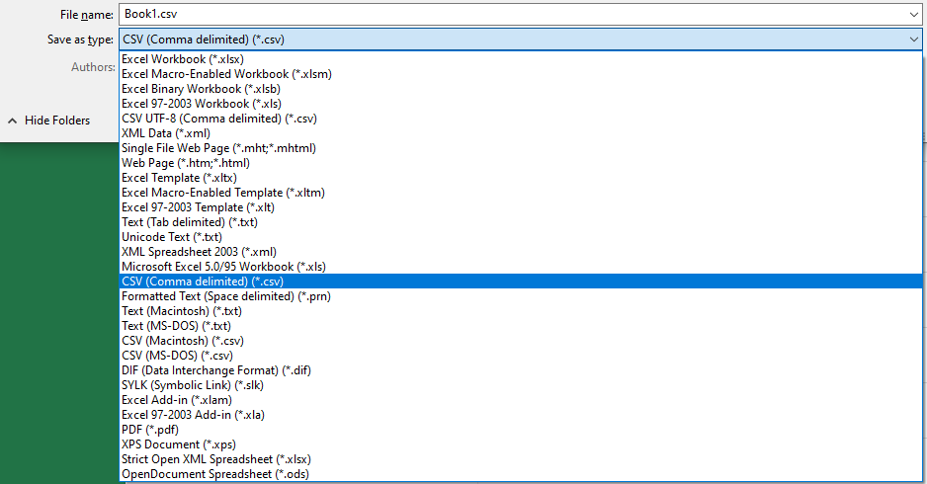

Locating Files on Disk
- When we read or write a file in R we need to tell the interpreter where to find the file.
- File paths can be relative or absolute
  - Absolute paths give the full path on disk
    - C:\Users\453526\data\data.csv or /home/453526/data/data.csv on Unix
  - Relative paths are relative to the path of the file reading/writing the external file
    - data.csv (in the same folder) or
../data.csv (one folder above)
- Absolute paths should generally be avoided!
  - They are not portable so they won't work on someone else's machine

More about absolute and relative paths

- Absolute paths begin with a drive letter (e.g. C:\ on windows) or a slash on Unix
- Relative paths tell the interpreter how to find a file relative to the current working directory
- The current working directory is usually the directory in which the script resides
- You can check and set the current working directory using the getwd() and setwd() functions in R.
- The dir() function will show all the files in the current working directory

Dataset
- To exemplify R options to import data we are going to use the Iris dataset with some small modifications
- This famous iris data set gives the measurements in centimeters of the variables sepal length and width and petal length and width, respectively, for 50 flowers from each of 3 species of iris. The species are Iris setosa, versicolor, and virginica.

Reading Delimited Files in Base R

- R provides the read.table() function to read delimited files
- Notice that the path is relative, this means it will look for the file in the current working directory
- The sep parameter tells R which character is used to delimit the data

‘’’’R
iris <- read.table("iris.csv", sep = ",")

path to file separator

‘’’

read.table()

- Many arguments can be passed. Read the documentation
- For example, the default behaviour of read.table is to not import the first column as header

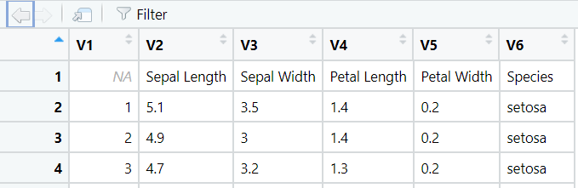

‘’’’R
iris <- read.table("iris.csv", sep = ",", header = TRUE)

‘’’

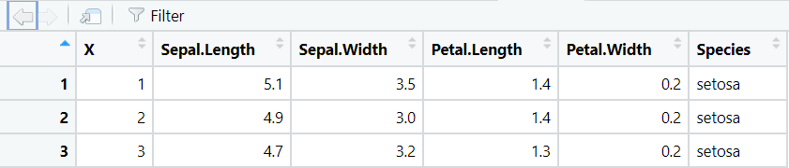

Spaces are replaced by dots

Inspecting a Data Frame
- It's always a good idea to inspect a data frame after you have imported it to make sure it looks as you would expect it to.
- The str() function (short for structure) is an easy way to get a summary of a data frame structure.
‘’’R
> iris <- read.table("iris.csv", sep = ",", header = TRUE)
> str(iris)
'data.frame': 150 obs. of 6 variables:
$ X : int 1 2 3 4 5 6 7 8 9 10 ...
$ Sepal.Length : num 5.1 4.9 4.7 4.6 5 5.4 4.6 5 4.4 4.9 ...
$ Sepal.Width : num 3.5 3 3.2 3.1 3.6 3.9 3.4 3.4 2.9 3.1 ...
$ Petal.Length : num 1.4 1.4 1.3 1.5 1.4 1.7 1.4 1.5 1.4 1.5 ...
$ Petal.Width : num 0.2 0.2 0.2 0.2 0.2 0.4 0.3 0.2 0.2 0.1 ...
$ Species : chr "setosa" "setosa" "setosa" "setosa" ...

‘’’

Automatic Type Conversions
- Notice that the Species column has been imported as a character type
- We can convert strings to factors with the stringsAsFactors parameter
‘’’R
> iris <- read.table("iris.csv", sep = ",", header = TRUE, stringsAsFactors = TRUE)
> str(iris)
'data.frame': 150 obs. of 6 variables:
$ X : int 1 2 3 4 5 6 7 8 9 10 ...
$ Sepal.Length : num 5.1 4.9 4.7 4.6 5 5.4 4.6 5 4.4 4.9 ...
$ Sepal.Width : num 3.5 3 3.2 3.1 3.6 3.9 3.4 3.4 2.9 3.1 ...
$ Petal.Length : num 1.4 1.4 1.3 1.5 1.4 1.7 1.4 1.5 1.4 1.5 ...
$ Petal.Width : num 0.2 0.2 0.2 0.2 0.2 0.4 0.3 0.2 0.2 0.1 ...
$ Species : Factor w/ 3 levels "setosa","versicolor",..: 1 1 1 1 1 1 1 1 1 1 ...

‘’’

Handling Missing Data when importing

Handling missing data when importing -1

- Missing values can cause problems when importing a dataset
- Consider the following data with missing values on the 4th line
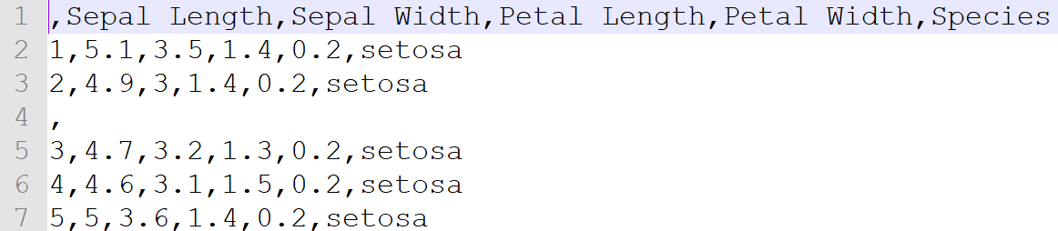

Empty row
- When importing it...

Handling missing data when importing - 2
- read.table() can automatically replace missing values with NAs
- The fill parameter lets us instruct R to fill in missing values

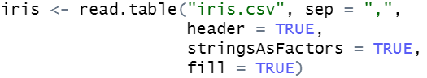
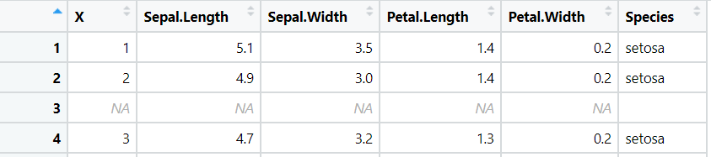

Handling missing data when importing - 3

- If we look further at the imported file, we can see that we have inconsistent ways of expressing missing data
- Some values are blank, one value is a question mark and some have been replaced with NA

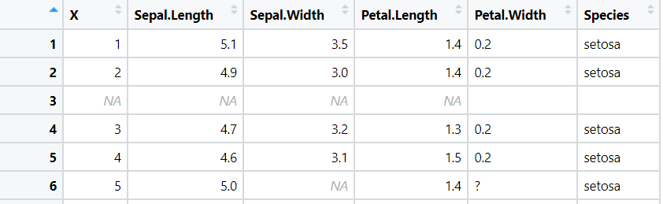

Highlighed = N/A + Empty cell + ?

Handling missing data when importing - 4
- This can be can fixed using the na.strings parameter.
- na.strings allows us to give a list of values that should be interpreted as NA
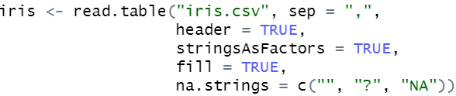

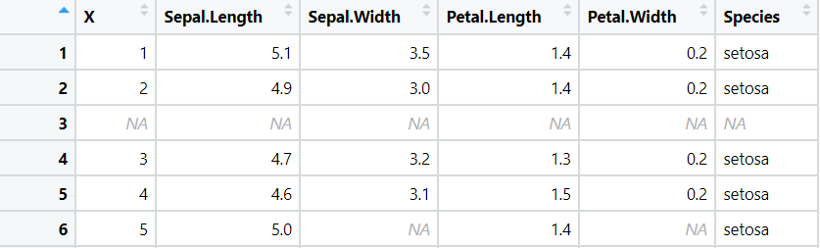

Similar importing functions
- The read.csv and read.delim functions are exactly the same as read.table but they have some different defaults
- Using these functions where applicable helps reduce clutter in your code
‘’’R

read.table :sep = "", header = FALSE, fill = FALSE
read.csv :sep = ",", header = TRUE, fill = TRUE
read.delim :sep = "\t", header = TRUE, fill = TRUE
‘’’

- Check the docs for more options. In Jupyter or RStudio you can run ?read.table to straight to the documentation.

The Readr Package

- The readr package provides the same functionality as the read.<format> functions
- It has some advantages over the base implementation
  - They are typically much faster (~10x)
  - Long running jobs have a progress bar, so you can see what’s happening.
  - They produce tibbles. Tibbles are data frames, but they tweak some older behaviours to make life a little easier, mainly printing and subsetting.

Reading CSVs with readr

- The readr function read_csv is the analogue to R's read.csv function
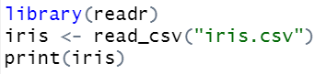
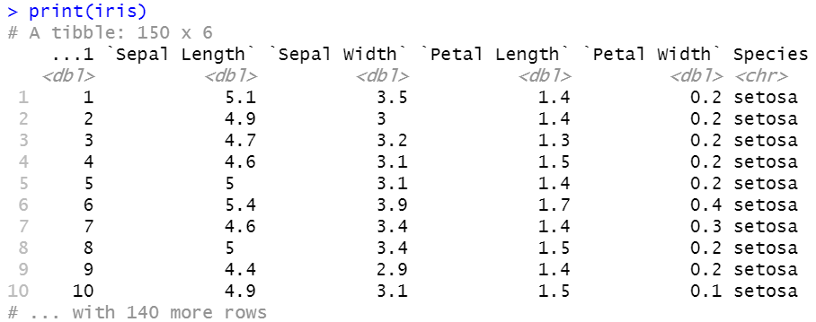

Viewing Import Problems with readr

- When we import data with read_csv we get a tibble
- You can use the problems() function on this tibble to view any import issues that were encountered
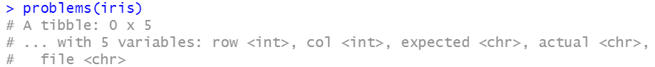

No problems in this case =)

readr column specifications

- The read_csv function also allows to specify column types during the import
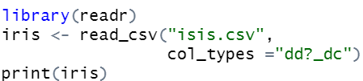
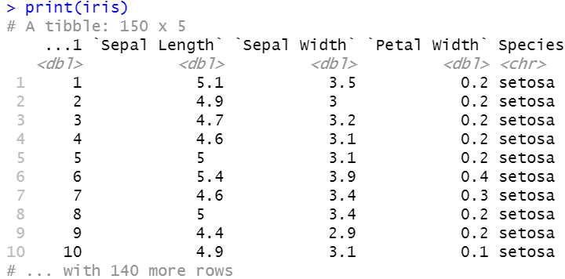

Available column specifications
The available specifications are: (with string abbreviations in brackets)
- col_logical() [l], containing only T, F, TRUE or FALSE.
- col_integer() [i], integers.
- col_double() [d], doubles.
- col_character() [c], everything else.
- col_factor(levels, ordered) [f], a fixed set of values.
- col_date(format = "") [D]: with the locale’s date_format.
- col_time(format = "") [t]: with the locale’s time_format.
- col_datetime(format = "") [T]: ISO8601 date times
- col_number() [n], numbers containing the grouping_mark
- col_skip() [_, -], don’t import this column.
- col_guess() [?], parse using the “best” type based on the input.

Other Functions in readr
- Readr supports seven file formats with seven read_ functions:
  - read_csv(): comma separated (CSV) files
  - read_tsv(): tab separated files
  - read_delim(): general delimited files
  - read_fwf(): fixed width files
  - read_table(): tabular files where columns are separated by white-space.
  - read_log(): web log files
- You can find out more about these functions by reading the https://www.rdocumentation.org/packages/readr/versions/1.3.1

Reading CSVs from the Web

- The most straightforward way to get data from the web in R is to read a csv from a URL.
- If we give read.csv a URL rather than a file path it will handle it for us
‘’’’R
url <- "https://archive.ics.uci.edu/ml/machine-learning-databases/
wine-quality/winequality-white.csv"
whineQualityWhite <- read.csv(url, sep = ";")
View(whineQualityWhite)
‘’’

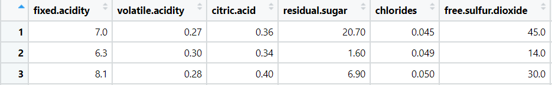

Working with Zipped Files

Working with Zipped Files

- Large data is often compressed when stored online (e.g. zip files)
- You can import a zip file using the following procedure
  - Download the file using the Base R function download.file
  - Unzip the file using the unzip function
  - Query the contents of the file using the list.files function
  - Read in the desired file to R

url <- "https://archive.ics.uci.edu/static/public/602/dry+bean+dataset.zip"
download.file(url = url, destfile = "my_file.zip") Destination file in the current working directory
unzip("my_file.zip")
list.files(path = "./DryBeanDataset")

Unzip in the current working directory -- List files in the path --

Working with Zipped Files

‘’’R
> url <- "https://archive.ics.uci.edu/static/public/602/dry+bean+dataset.zip"
> download.file(url = url, destfile = "my_file.zip")
> unzip("my_file.zip")
> list.files(path = "./DryBeanDataset")
[1] "Dry_Bean_Dataset.arff" "Dry_Bean_Dataset.txt" "Dry_Bean_Dataset.xlsx
‘’

Working with Zipped Files

> url <- "https://archive.ics.uci.edu/static/public/602/dry+bean+dataset.zip"
> download.file(url = url, destfile = "my_file.zip")
> unzip("my_file.zip")
> list.files(path = "./DryBeanDataset")
[1] "Dry_Bean_Dataset.arff" "Dry_Bean_Dataset.txt" "Dry_Bean_Dataset.xlsx”

Uncommon data type that includes additional metadata that describes the dataset's attributes

library(readxl) Package able to read xlsx files
# Read the first sheet of the Excel file
data <- read_excel("./DryBeanDataset/Dry_Bean_Dataset.xlsx", sheet = 1)
View(data)

Working with Zipped Files

Dry_Bean_Dataset
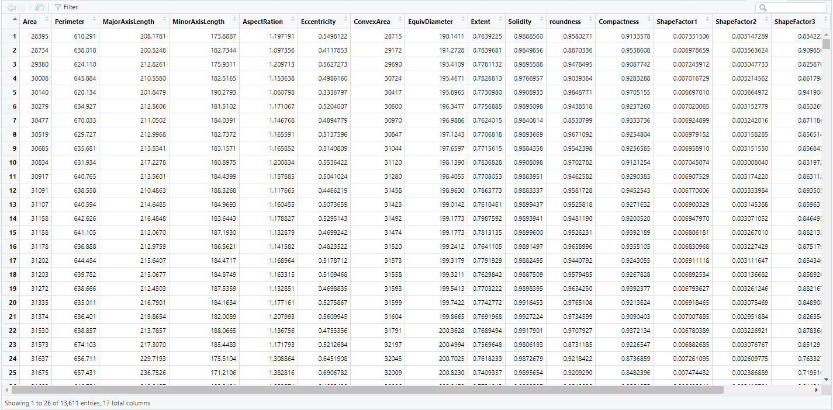

Scraping Data
- Data Scraping is how we refer to retrieving data from the internet
- Being able to scrape data is a very important part of working with data
- This is often how new datasets are created!

Scraping HTML Tables
- Data is often displayed online in HTML tables
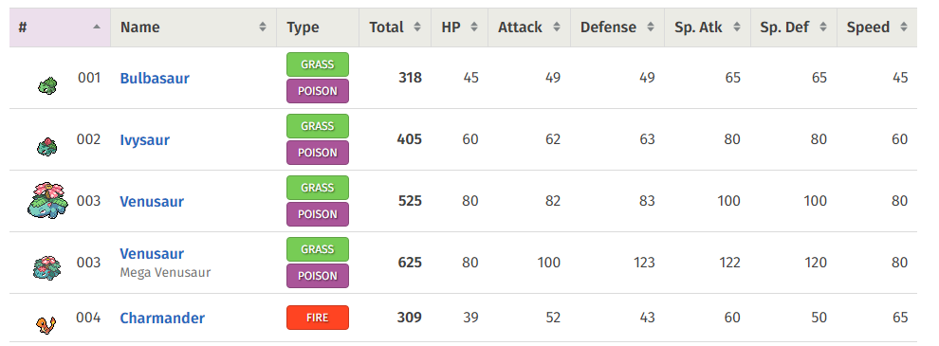

- The rvest package can be used to import tables into R and store them as a dataframe

Scraping HTML tables

- The first step is to fetch the HTML of the webpage. This can be done using the read_html function
‘’’R
library(rvest)
webpage <- read_html("https://pokemondb.net/pokedex/all")

‘’’
- The next step is to identify the tables within the code
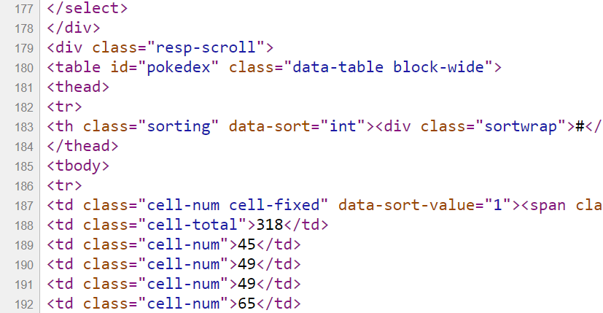

Scraping HTML tables

- The function html_nodes identifies all HTML nodes in the webpage object that match the <table> tag.
- It looks for tables in the webpage's structure and stores them in tableNodes.
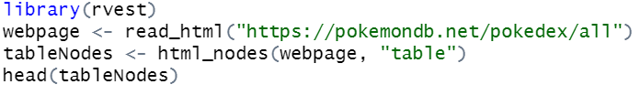

Scraping HTML tables
- The final step is to extract the actual table(s) using the identifier(s) contained in the list:
‘’’R
#install.packages('rvest')
library(rvest)
webpage <- read_html("https://pokemondb.net/pokedex/all")
tableNodes <- html_nodes(webpage, "table")
table <- html_table(tableNodes)
pokemonData <- table[[1]]
View(pokemonData)

Converts the identified HTML table nodes into a list of data frames
‘’’

Scraping HTML tables

- The final step is to extract the actual table(s) using the identifier(s) contained in the list:

‘’’R
#install.packages('rvest')
library(rvest)
webpage <- read_html("https://pokemondb.net/pokedex/all")
tableNodes <- html_nodes(webpage, "table")
table <- html_table(tableNodes)
pokemonData <- table[[1]]
View(pokemonData)

Extracts the first table from the list of tables (since multiple tables may exist) and stores it in pokemonData.
‘’’

Scraping HTML tables

- The final step is to extract the actual table(s) using the identifier(s) contained in the list:

‘’’R
#install.packages('rvest')
library(rvest)
webpage <- read_html("https://pokemondb.net/pokedex/all")
tableNodes <- html_nodes(webpage, "table")
table <- html_table(tableNodes)
pokemonData <- table[[1]]
View(pokemonData)

Opens a viewer window in RStudio to display the content of pokemonData
.

‘’’
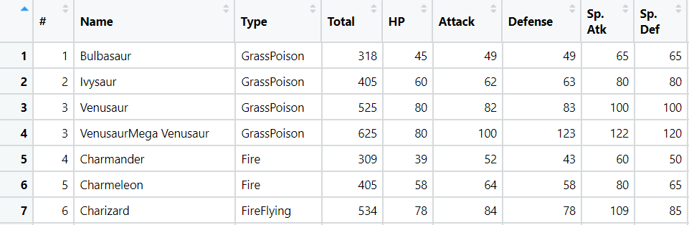

Exporting Data

- After importing the data into R and carrying out some processing / computation, we may wish to permanently store our work or share it with others.
- There are many different ways that this can be achieved depending on the desired format of the output.
- Let’s use the pokemonData data frame, generated earlier, to explore some of the basic options available.

Exporting Data -1

The functions write.table and write.csv come built-in to R.
write.table(pokemonData, "pokemon.txt", row.names = FALSE)

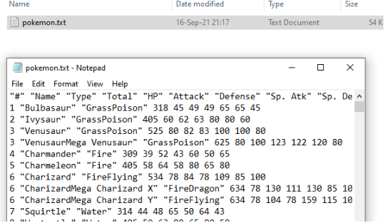

Exporting Data - 2
- The functions write.table and write.csv come built-in to R.
‘’’R
write.csv(pokemonData, "pokemon.csv", row.names = FALSE)

‘’’
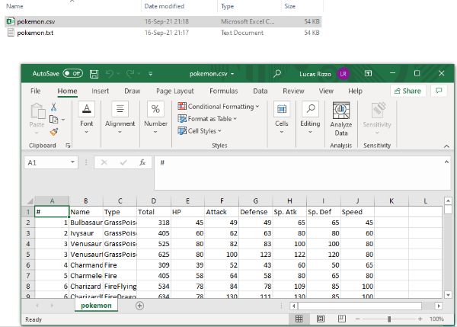

The RData Format

- R objects can be saved using the native RData format.
- An Rdata file is a binary file, whereas csv files, for example, are text files.
- Advantages of Rdata format is that it is more compact, faster to read, and can store any type of R data structure. Furthermore, you can store several objects into one Rdata file.
- The main disadvantage is that it is a format which is incompatible with other statistical systems or software. So you won't be able to send data in this format to someone who is not using R.

The RData and rds Format
- The RData format is used to save multiple objects and functions present in the global environment
  - The .rda file is short for RData
- The .rds file is suitable for saving a single R object
- Base R provides the load function to import .RData/.rda files and readRDS for .rds files
‘’’R
load("data.RData")
readRDS("data.rds")
‘’’
- The readr package offers the read_rds function for importing .rds files
‘’’R
library(readr)
read_rds("data.rds")

‘’’

Exporting Data

- It might be better to store data in the native R format.
- For example, if your dataset has one column of factors and other columns with characters, there will be no easy way to restore that metadata from a CSV.
- There are two options for that
  - If only saving a single R object, use saveRDS {base} or write_rds {readr}.
    - The only major difference between the two is that write_rds() does not compress the file by default.
  - If saving multiple R objects, use the save function {base}, with the names of the objects collected in a character vector.

Exporting Data - 1
‘’’R
saveRDS(pokemonData, "pokemon.rds")
write_rds(pokemonData, "pokemon_readr.rds")
name <- pokemonData$Name
type <- pokemonData$Type
save(list = c("name", "type"), file = "pokemon.RData")
‘’’

Summary
- Reading different file formats
  - Handling missing data when reading data
  - Identifying problems when reading data
- Exporting and loading rds and RData formats
- Scraping HTML tables

More DataCamp courses about R, importing data, missing values, and scraping data

- Introduction to R
- Intermediate R
- Introduction to importing data in R
- Dealing with missing data in R
- Web scraping in R

Questions?

Lab
- Lab 3

Week 4 - Intro SQL and aggregate queries

Indicative Schedule

Week 1 | Set up environment and R notebook
Week 2 | Review Python and practice
Week 3 | Review R
 | Importing data with R
Week 4 | Intro SQL and aggregate queries
Week 5 | Databases and scripting languages (To be submitted)
Week 6 | Interpreting Data (summary statistics, data visualisation)
Week 7 | Review week
Week 8 | Data manipulation in R
 | Pandas and Numpy
Week 9 | Data visualisation in Python
 | Data processing (regular expressions)
Week 10 | Audio data (R and tuneR) (To be submitted)
Week 11 | Image data (Python and skimage) (To be submitted)
Week 12 | Time series (Python and Pandas)
Week 13 | Working on Assignment
 | Assignment deadline

Overview
- Database refresher
  - Tables, columns, keys
- SQL databases and R dataframes
- Data modification language
- Basic data definition language
- Relationships
- Aggregate queries

PostgreSQL set up
- You can download PostgreSQL here https://www.postgresql.org/download/
- Open the pgAdmin tool. This is the administration and management tools for the PostgreSQL database.
Password = password0134!
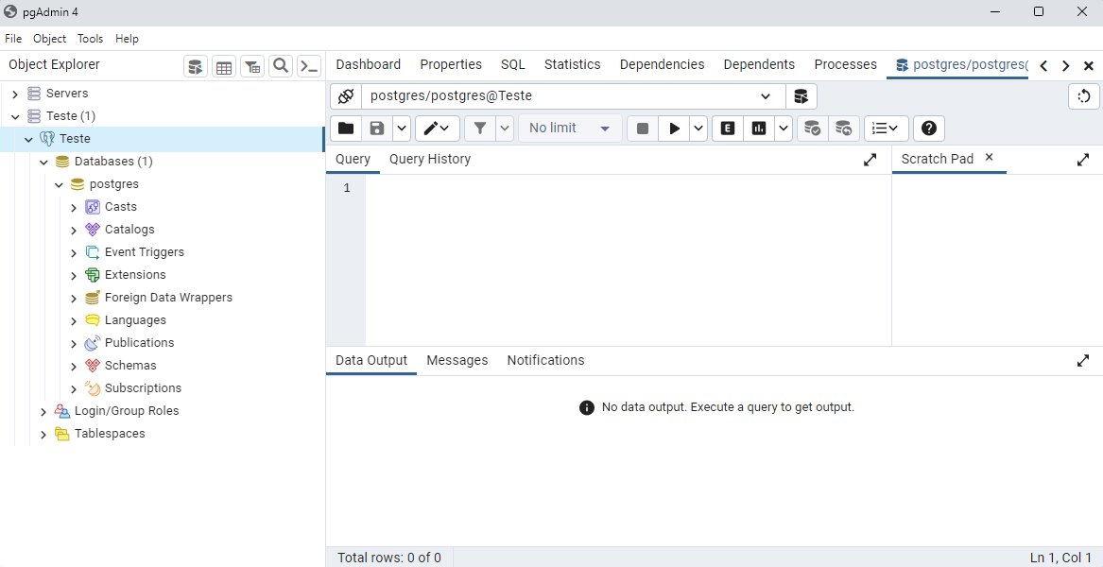

SQL Databases and R DataFrames
- An R Dataframe is a like a lightweight SQL table
- A dataframe consists of:
  - columns (with a type) which define the dataframe
  - rows, or values, which make up the data
- Dataframes are often flat, we tend to have wide dataframes containing all the columns we need in a single place
- R dataframes usually only live for as long as the R session

SQL Databases and R DataFrames
- An SQL table is heavily optimized and more complex than a R dataframe
- Like R dataframes, SQL tables consist of strongly typed columns and rows
- Databases are usually normalized. We tend to have one table per thing (entity) and we join those tables together when we query SQL tables live on the hard drive; they are persistent.

ERD

- SQL databases depend on the structure of entities and the pattern of relationships between them.
- It is designed to avoid data redundancy and increase data integrity.
- An Entity Relationship Diagram (ERD) lets you see how different entities relate to each other in an application or a database
- It is implementation independent

Different types of ERD
Conceptual model
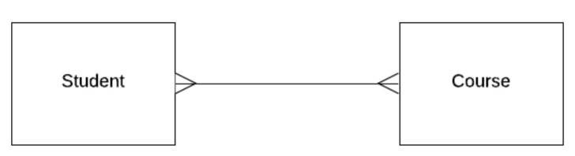

Logical Model
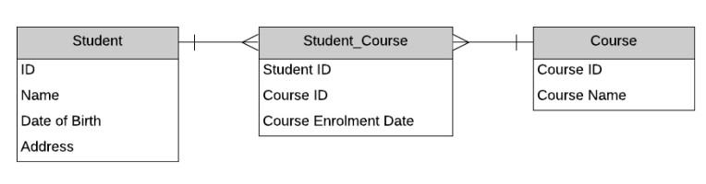
A Physical Model
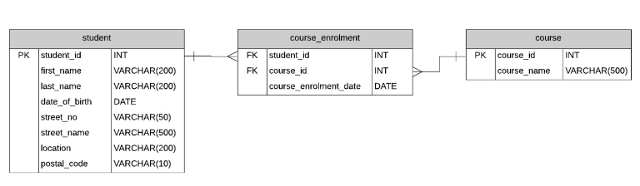

- Examples of notation and models can be seen here
https://www.databasestar.com/entity-relationship-diagram/

Why Structured?
- SQL enforces strict data structures
- All items in a collection have the same set of properties
- Each item’s properties have the same type
- Missing values must be explicitly allowed

Flavours of SQL
- SQL is actually a family of closely related languages
- Oracle SQL
  - SELECT * FROM
  - Students
  - ORDER BY dob
  - FETCH FIRST 10
  - ROWS ONLY;

- MS SQL
  - SELECT TOP 10 *
  - FROM Students
  - ORDER BY dob;
- PostgreSQL
  - SELECT * FROM
  - Students
  - ORDER BY dob
  - LIMIT 10;

- SQL has a standard of the American National Standards Institute (ANSI), although implementations don’t follow it fully

Data Types

R
- Double
- Integer
- Boolean
- Character
- Date
- Factor
- NA
Python
- Float
- Integer
- Boolean
- String
- Datetime module
- Pandas categorical data type
- NA

SQL
- NUMERIC(precision,
scale)
- INT
- BOOLEAN
- CHAR(Size),VARCHAR (Size), TEXT
- DATE
- Foreign Key (kind of, by using a table of categories)
- NULL

SQL Number

- In SQL, you must specify exactly how much space you want to use to store a number
- Precision is the number of digits in a number
- Scale is the number of those digits to the right of the decimal place.

- What precision and scale would you use for…
  - A random number seed which is a whole number 8 digits long?
  - Price of stock less than €1000?
  - A number between 0 and 1, to 5 decimal places?
  - A boolean column?

SQL Number

- What precision and scale would you use for…
  - A random number seed which is a whole number 8 digits long? (8,0)
  - Price of stock less than €1000? (5,2)
  - A number between 0 and 1, to 5 decimal places? (6,5)
  - A boolean column? (1,0)
Comment:
1) 8 digits and no decimals ] > 8 precisin and 0 scale
2) Max number is 999.99 = > 5 precision and 2 scale….
4) only 1 digit, = > so 1 precision and 0 scale

VARCHAR

- Strings are represented in a database using the VARCHAR type
- The varchar size specifies the maximum number of characters allowed
‘’’SQL
CREATE TABLE Customer (
FirstName VARCHAR (50)
);
‘’’
- String literals must be written using single quotes
SE’’’SQLLECT * FROM Customer WHERE FirstName = 'Lucas
‘’’

DATE

- We can add date information to a column using the DATE datatype
- We can specify dates as a string and PostgreSQL will automatically parse them
- It’s better to use the TO_DATE() function and specify our format manually
‘’’SQL
SELECT * FROM Orders WHERE OrderDate > '01-Nov-20'
SELECT * FROM Orders WHERE OrderDate > TO_DATE('2020-11-01','YYYY-MM-DD')
‘’’

NULL
- The value NA in R corresponds to PostgreSQL NULL value
- R always allows NA values in a dataframe, but in SQL columns must explicitly forbid them
‘’’SQL
CREATE TABLE contacts(
id INT,
first_name VARCHAR(50) NOT NULL,
last_name VARCHAR(50) NOT NULL,
email VARCHAR(255) NOT NULL,
phone VARCHAR(15),
PRIMARY KEY (id)
);
‘’’

Primary Key

- Each table in SQL should have a primary key
- A primary key is a column (or group of columns) which uniquely identify the row
- Primary keys can be actual features of the entity (i.e. a student number), or an auto-generated value (i.e. ID)
- Technically, a primary key constraint is the combination of a not-null constraint and a UNIQUE constraint.

Primary Key
‘’’SQL
CREATE TABLE po_headers (
po_no INTEGER PRIMARY KEY,
vendor_no INTEGER,
description TEXT,
shipping_address TEXT
);
CREATE TABLE po_items (
po_no INTEGER,
item_no INTEGER,
product_no INTEGER,
PRIMARY KEY (po_no, item_no)
);

‘’’

Selecting Data

- To retrieve data from our tables we use the SELECT command
‘’’SQL
SELECT col1, col2, col3 FROM Table
- We can use * as a shortcut to select all columns
‘’’

Selecting and Ordering Data
- We can sort results in SQL using the ORDER BY clause
- This will sort results by a given column(s) in ascending order by default
- The DESC keyword reverses the default order
- The ORDER BY clause always comes last in a statement
‘’’SQL
SELECT * FROM Customer
ORDER BY FirstName, LastName;
SELECT * FROM Customer
ORDER BY LastLoginDate DESC;
‘’’

Filtering Data

- We can use a WHERE clause to filter the data we retrieve
‘’’SQL
SELECT email FROM Customer WHERE marketingOptIn = 1

‘’’

Filtering Data

- The WHERE clause can be combined with AND, OR, and NOT operators.
- PostgreSQL lets us use some basic wildcard matching on varchars using LIKE
- The % symbol is equivalent to .* in a RegEx (match any number of characters)
- The _ symbol is equivalent to . in a RegEx (match a single character)

Filtering Data
‘’’SQL
SELECT * FROM Customers WHERE Name = 'Lucas' AND Surname = 'Rizzo'
SELECT * FROM Customers WHERE Name LIKE '%ca%' OR Name LIKE 'L%s'
SELECT * FROM Customers WHERE Name LIKE 'L___s'
‘’’

Inserting Data

- We use an INSERT statement to add data to our tables
‘’’SQL
INSERT INTO Customer (id, firstName, lastName, marketingOptIn)
VALUES (1123, 'Lucas', 'Rizzo', 0);

‘’’

Updating Data

- We can change the values in a database using an UPDATE statement
‘’’SQL
UPDATE Customer SET marketingOptIn = 0 WHERE marketingOptIn IS NULL
‘’’

Deleting Data
- We can delete values in a database using a DELETE statement
‘’’SQL
DELETE FROM Customer WHERE id = 1123
‘’’

Dropping Tables

- To permanently remove a table from the database we use the DROP command
‘’’SQL
DROP TABLE Customer
‘’’

Altering Tables
- We can change the definition of a table using the ALTER TABLE command
‘’’SQL
ALTER TABLE Customer ADD dob DATE NULL;
‘’’

Foreign Key
- Tables in a relational databases are related to each other
- Every order in a sales database was placed by a customer
- We can say that order belongs to the customer
- We can represent this using a foreign key

Creating Tables

- Suppose we want to model a very basic version of IMDB where we store information about movies and actors
- We’ll start with two tables
  - Movie
  - Actor

Creating Tables

- >> First, we need to think about what columns we’ll need for movie

  - movieTitle, Year, Director, Budget, Profit

- >> second - Next, what are the datatypes for those columns?
  - movieTitle
  - Year
  - Director
  - Budget
  - Profit

- >>> second two >--- Next, what are the datatypes for those columns?
  - movieTitle VARCHAR(100)
  - Year DATE
  - Director VARCHAR(100)
  - Budget Numeric(12, 2)
  - Profit Numeric(12, 2)
  - Comment
    - Bidget Precision and scale > 9, 999,999,999.99 =>>
      - Up to 9 billion budget = 12 precision and scale 2 (12,2)
- >>> third >> Are we missing anything?
  - movieId Numeric(4)
- >> fourth >> What about Actor? Which attributes can we define?
  - >>
  - ActorID Numeric(4)
  - ActorName VARCHAR(100)

‘’’SQL
CREATE TABLE Movie(
movieID NUMERIC(4),
movieTitle VARCHAR(100),
year NUMERIC(4),
director VARCHAR(100),
budget NUMERIC(12,2),
profit NUMERIC(12,2),
PRIMARY KEY (movieID)
);

‘’’’

‘’’SQL
CREATE TABLE Actor(
actorID NUMERIC(4),
actorName VARCHAR(100),
PRIMARY KEY (actorID)
);

‘’’’

Relationships
- We now have a table to store movies and a table to store actors
- How do we store information about which actors acted in each movie?

Week 5

Links and Rerences
- General – from early chat
  - XLS Semester with all courses and all links > https://docs.google.com/spreadsheets/d/1lflFEgHnTlqOd_ZDnIWwgpTnMqc95MPo/edit?gid=1407562868#gid=1407562868
- week 1 >>
  - Content:
    - ppt 0 + ppt 1 + titanic files https://drive.google.com/drive/folders/1FlUlyncqCDS0dE_FJcR_9ICcGoVEnnS7?usp=sharing
  - Labs
    - R
      - R Markdown have a look [here](https://rmarkdown.rstudio.com/lesson-1.html )
      - [Titanic Dataset](https://web.stanford.edu/class/archive/cs/cs109/cs109.1166/stuff/titanic.csv
      - [modulus (%%) operator](https://en.wikipedia.org/wiki/Modulo_operation
      - [kaggle titani notebook](https://www.kaggle.com/romabash/titanic-data-visualization#3.-Look-at-Survival-Rate-by-Ticket-Class
    - Ipynb
      - [pandas](https://pandas.pydata.org/docs/)
      - "source": ["url=\"https://web.stanford.edu/class/archive/cs/cs109/cs109.1166/stuff/titanic.csv\"\n
- pandas documentation linked [here](https://pandas.pydata.org/docs/index.html
- matplotlib documentation [here](https://matplotlib.org/stable/contents.html )
- jyupyter notebooks - [here](https://www.datacamp.com/community/tutorials/markdown-in-jupyter-notebook)

- Week 2 >> Content > ppt 2 + python practice
  - https://tinyurl.com/5b3p77v4
- General Course
  - • DIT MSc Website >> https://sites.google.com/view/mscincomputersciencetu059tu060/home
  - • Module Catalogue >> https://sites.google.com/mydit.ie/msccomputing/home
  - • MSc Dissertation Website >> http://brightspace.tudublin.ie/
  - • Team Project Website >> https://sites.google.com/mydit.ie/msccomputing/home
  - • MSc Blog >> http://ditmsc.blogspot.com/
  - Notice Board – blogspot - or all MSc/PgCert in Computer Science Students - TU Dublin - TU059/TU060/TU256
    - https://ditmsc.blogspot.com/2020/?m=1

Week 1
- Week 2 >> https://tinyurl.com/5b3p77v4

Books
  - Wickam & Grolemund, R for Data Science, O’Reilly Press, 2016. Free at https://r4ds.had.co.nz/
  - Andrew O. Finley, Jeffrey W. Doser, Vince Melfi, R Programming for Data Sciences. 2020. Free at https://bookdown.org/rdpeng/rprogdatascience/
  - McKinney, Wes. Python for data analysis: Data wrangling with Pandas, NumPy, and IPython. " O'Reilly Media, Inc.", 2022. Open access HTML https://wesmckinney.com/book
    - Eamonn: This is book he recommends for more traditional book approach, he will take samples from here…

Week 1

Slide counts
- Week 1 =
  - Ppt 1 = 15 slides
  - Ppt 2 = 25 slides

Completed
- Week 1
  - Recording – there is no recording… didn’t record.. aid there was no content anyway
  - Content - completed
  - Labs and Exercises
- Week 2
  - Recording - competed
  - Content - completed
  - Labs and Exercises
- Week 3
  - Recording -
  - Content -
  - Labs and Exercises

Questions?
- eamonn : Will assessments need to eb done in python or R, or can we choose?
  - Where should I focus my time?
  - Comment> answer >> for assignemnts > use whatever language you prefer Ror Python….
- Eamonn: Is it easy to convert python / jupyter notebook to an R md file? Then convert to html (knit) so can publish standalone html in quarto?

